CQUniversity Australia
COIT20245 – Introduction to Programming

Assignment 2: Project
Term 2, 2025

Assessment Due Date: 28 September 2025
Word Count (Actual): 9,292

Student Name: Joshnell Briggs Zareno
Student Number: 12292861
CQUniversity Email: j.zareno@cqumail.com

Local Lecturer: Dr. Aries Tao
Unit Coordinator: Dr. Paul Kwan

Phase-1: Implement Book Catalogue System Tasks
- Data Structure: Design the book catalogue as a list of dictionaries to store book records. To see how a Book Record should look like, refer to the attributes provided under Book Catalogue above.
- Core functions are outlines below:
1. def load_catalogue(csv_filename) -> List[dict]
# Loads book records from a CSV file. # Returns the catalogue as a list of dictionaries.
Answer:
def load_catalogue(filename: str) -> List[dict]:
"""
Load a book catalogue from a CSV file.

Args:
filename (str): The CSV file containing book records
(Title, Author, Year, ISBN, Copies).

Returns:
List[dict]: A list of book dictionaries.

Raises:
FileNotFoundError: If the file does not exist.
KeyError: If the file format is invalid.
ValueError: If Year or Copies cannot be converted to integers.
"""
catalogue = []
try:
with open(filename, mode="r", newline="", encoding="utf-8") as file:
reader = csv.DictReader(file)
for row in reader:
catalogue.append({
"Title": row["Title"],
"Author": row["Author"],
"Year": int(row["Year"]),
"ISBN": row["ISBN"],
"Copies": int(row["Copies"])
})
except FileNotFoundError:
print(f"Error: {filename} not found.")
except KeyError:
print(f"Error: {filename} is not a valid book catalogue file.")
except ValueError:
print(f"Error: Invalid data format in {filename}.")
except Exception as e:
print(f"Unexpected error: {e}")
else:
print(f"Catalogue loaded successfully from {filename}.")
return catalogue

Explanation:
The function load_catalogue() accepts a parameter filename in string format. The file is expected to be in CSV format containing book records with the fields: Title, Author, Year, ISBN, and Copies.
The function begins by opening the CSV file using the open() function in read mode. A variable named reader is then created using csv.DictReader(), which reads the CSV file as a sequence of dictionaries (in this case, from books.csv). A for loop is used to append the values from reader into the variable catalogue.
The function implements error handling using the try–except–else structure:
- try block – Contains the main logic for opening the file, reading its contents, and parsing records into the catalogue list.
- except blocks – Handle different types of errors that may occur:
  - FileNotFoundError – Triggered when the specified file does not exist. The program prints:
“Error: {filename} not found.”
  - KeyError – Triggered when the CSV file does not contain the expected column names (e.g., Title, Author, Year, ISBN, or Copies). The program prints:
“Error: {filename} is not a valid book catalogue file.”
  - ValueError – Triggered when the values in the Year or Copies fields cannot be converted into integers. The program prints:
“Error: Invalid data format in {filename}”.
  - Exception – triggered if an unexpected error occurs that isn’t covered by the other specific error types, printing:
“Unexpected error: {e}”
- else block – Executes only if no exceptions are raised in the try block. In this case, the program prints the confirmation message:
“Catalogue loaded successfully from {filename}”.
Finally, the function returns the variable catalogue, which contains the list of dictionaries created from the records in the CSV file.
Testing:
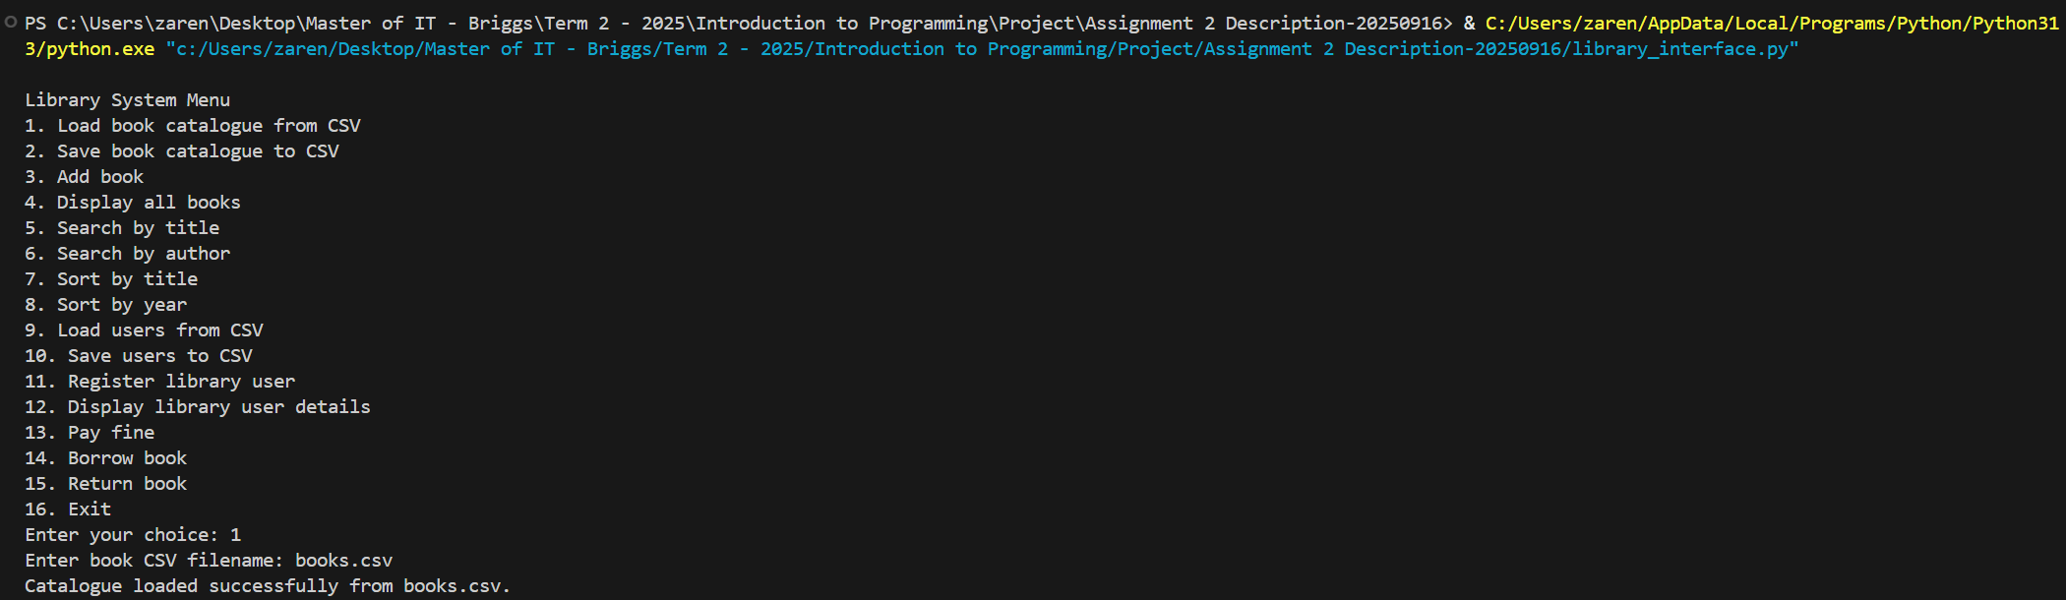
The screenshot above shows the result after executing library_interface.py, selecting option 1, and entering the filename books.csv. After this, the program displays the confirmation message: “Catalogue loaded successfully from books.csv”.
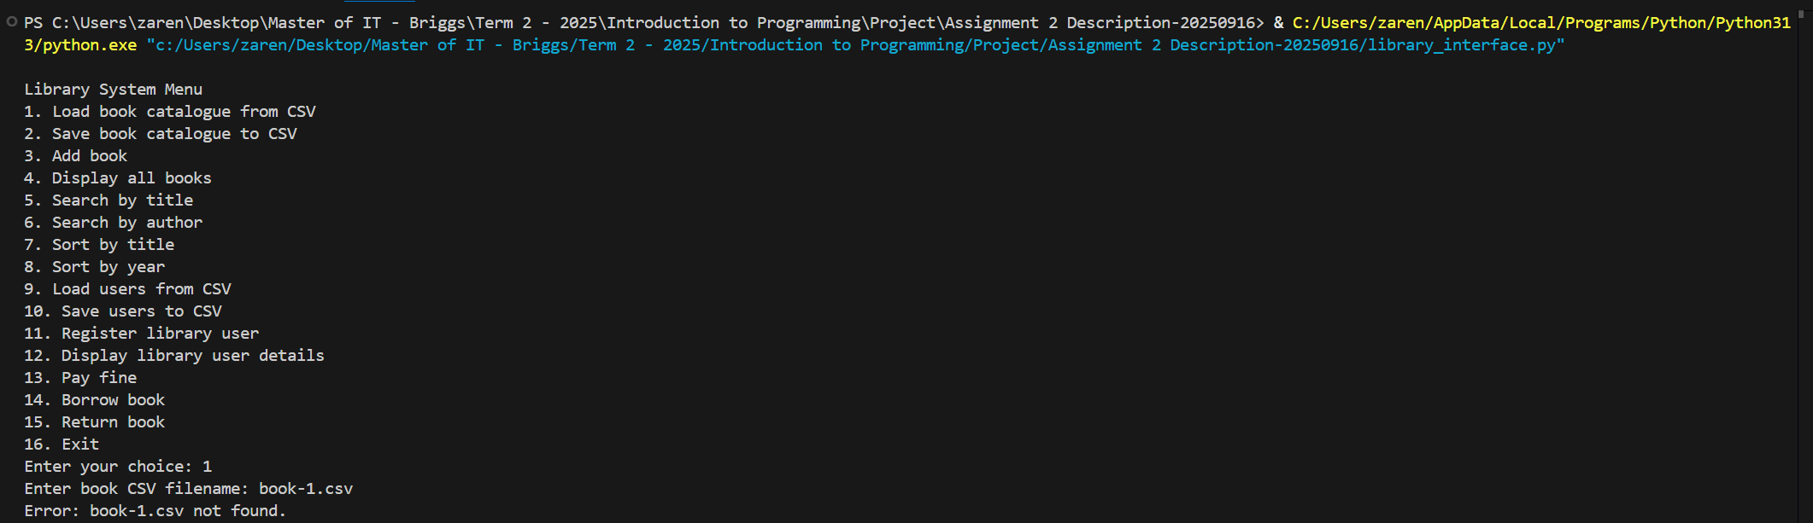
The screenshot above shows the error handling for FileNotFoundError.
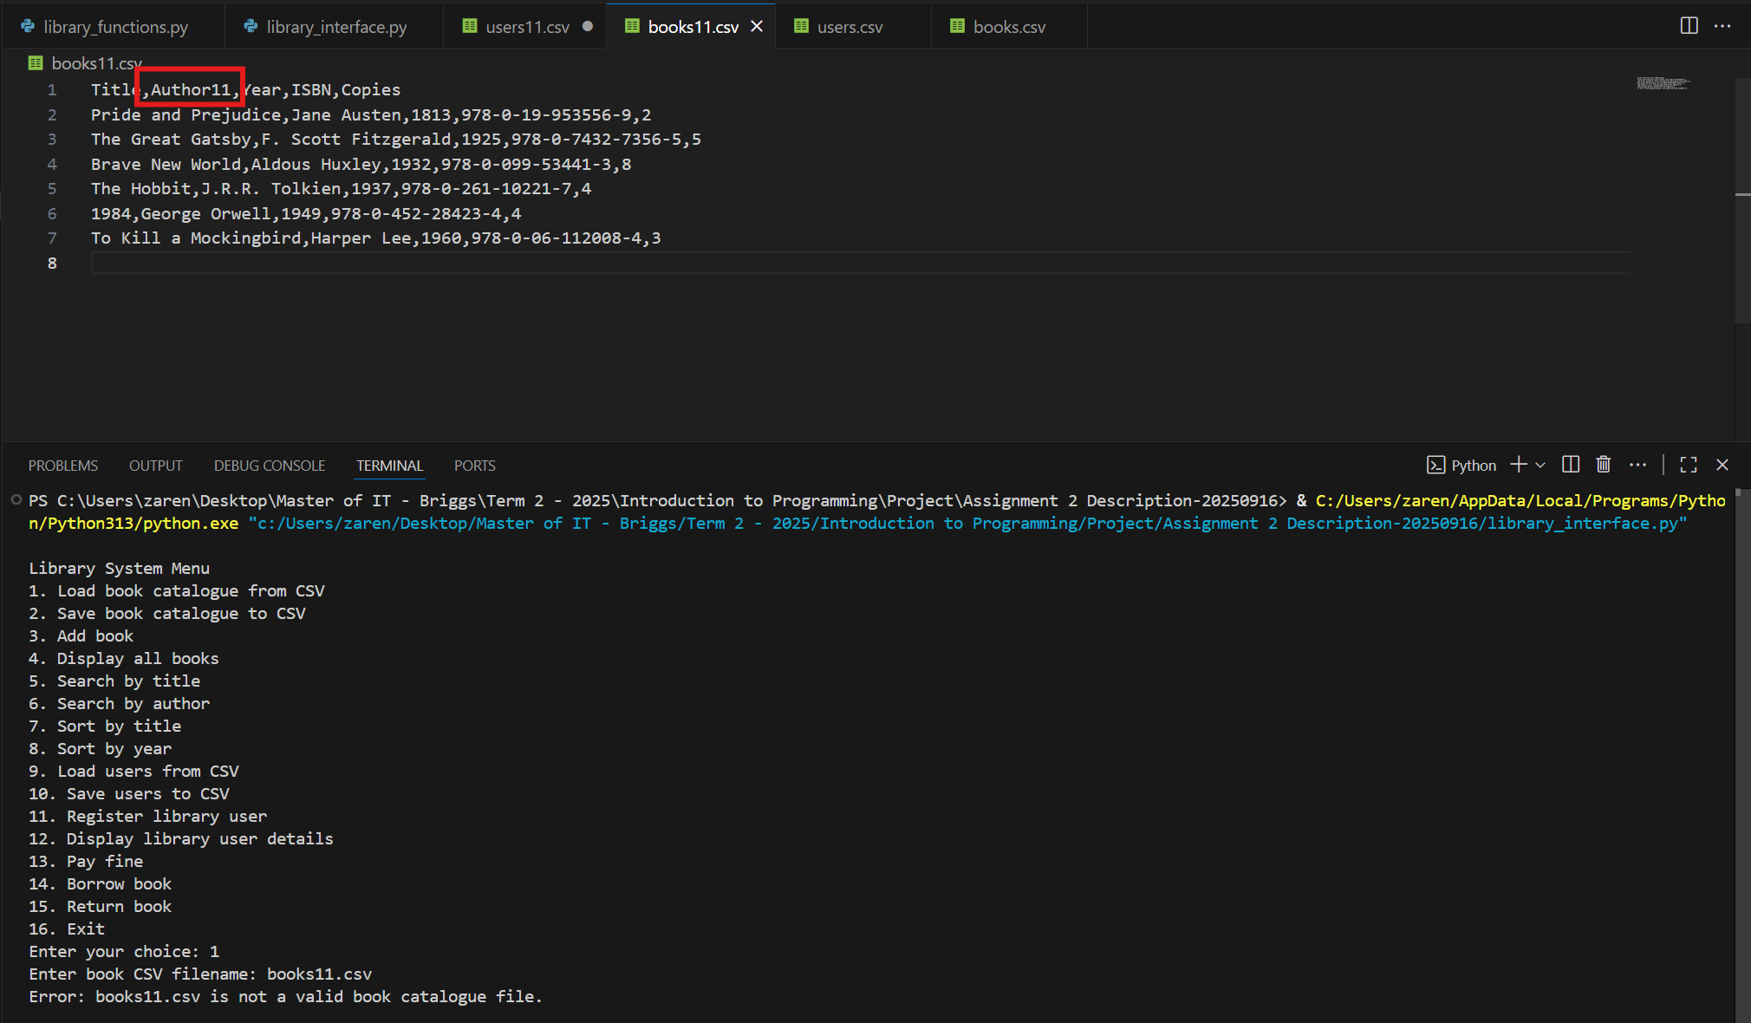
The screenshot above demonstrates the error handling for a KeyError. In this example, the file books11.csv was used, and one of the headers was intentionally modified to be incorrect to trigger the error handling.
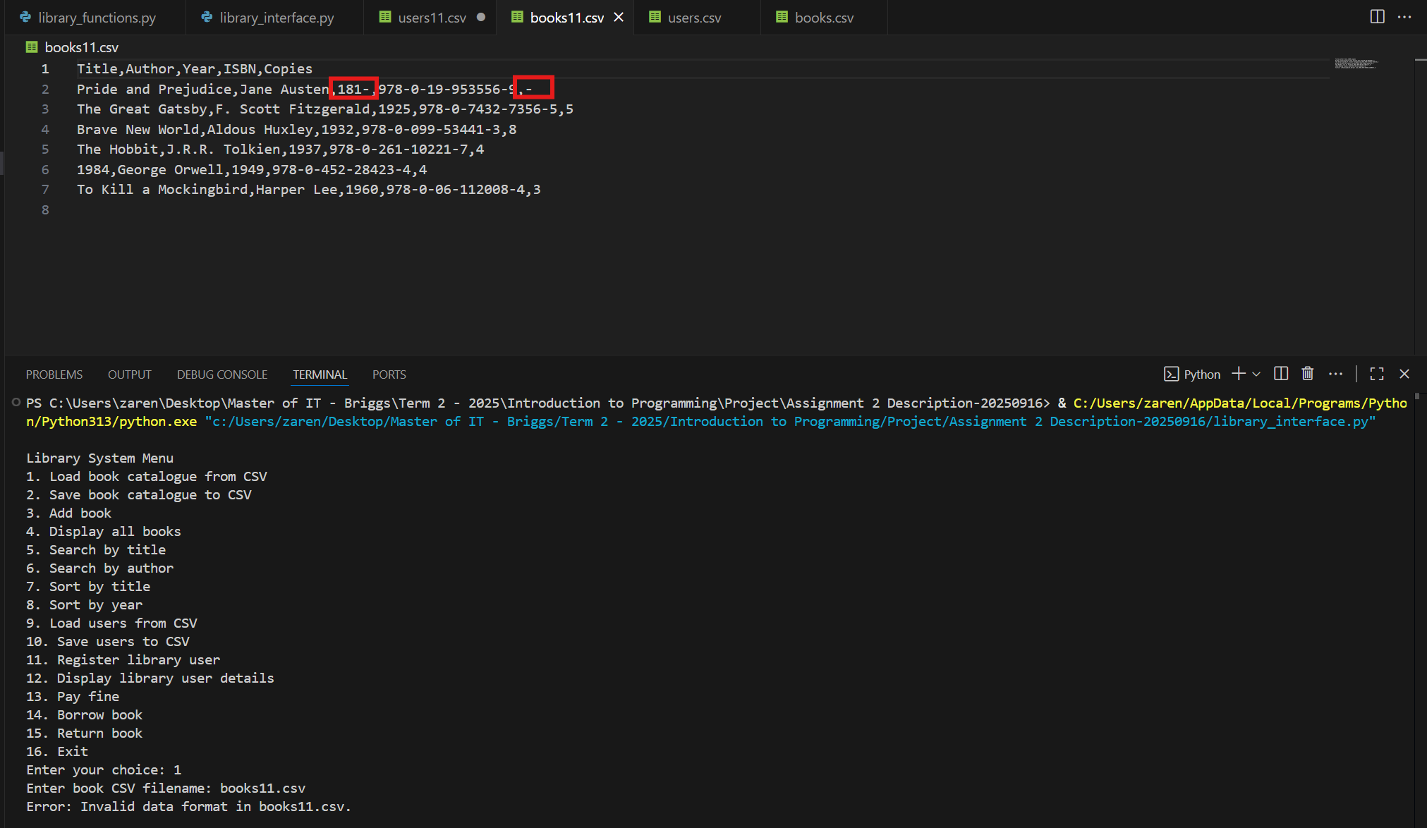
The screenshot above demonstrates the error handling for a ValueError. In this example, the file books11.csv was used, and the values for Year and Copies were intentionally modified to trigger the error. This occurred because both fields are expected to be converted into integers, and invalid data in these columns causes the program to raise a ValueError.

2. def save_catalogue(csv_filename, catalogue) -> None
# Saves the book catalogue to the same CSV file.
Answer:
def save_catalogue(filename: str, catalogue: List[dict]) -> None:
"""
Save a book catalogue to a CSV file.

Args:
filename (str): The CSV file to save the catalogue to.
catalogue (List[dict]): A list of book dictionaries containing
(Title, Author, Year, ISBN, Copies).

Returns:
None

Raises:
OSError: If the file cannot be created or written to.
"""
try:
with open(filename, mode="w", newline="", encoding="utf-8") as file:
fieldnames = ["Title", "Author", "Year", "ISBN", "Copies"]
writer = csv.DictWriter(file, fieldnames=fieldnames)

writer.writeheader()
for book in catalogue:
writer.writerow({
"Title": book["Title"],
"Author": book["Author"],
"Year": book["Year"],
"ISBN": book["ISBN"],
"Copies": book["Copies"]
})
except OSError:
print(f"Error: Could not save to {filename}.")
else:
print(f"Catalogue saved successfully to {filename}.")
Explanation:
The function save_catalogue() accepts two parameters: filename, provided as a string, and catalogue, which is a list of dictionaries. The file is expected to be in CSV format, and the catalogue should contain book records with the fields: Title, Author, Year, ISBN, and Copies. The function begins by opening the CSV file in write mode using the open() function. A DictWriter object named writer is then created and initialized with the field names corresponding to the book records. The writeheader() method is called to insert the column headers into the file. Following this, a for loop iterates through each book in the catalogue and writes its details into the CSV file using the writerow() method.
Error handling is implemented using the try–except–else structure:
- try block – Contains the main logic for creating/opening the file, preparing the writer, and saving the book records.
- except block – Catches an OSError, which is triggered if the file cannot be created or written to. In such a case, the program prints:
“Error: Could not save to {filename}”.
- else block – Executes only if no exceptions occur in the try block. If the file is successfully saved, the program prints the confirmation message:
“Catalogue saved successfully to {filename}”.
Testing:
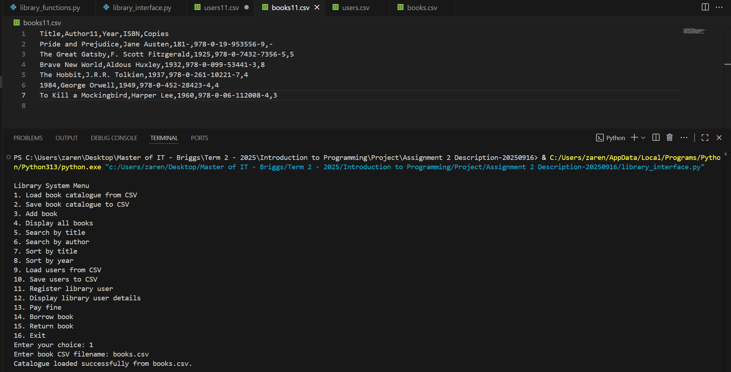
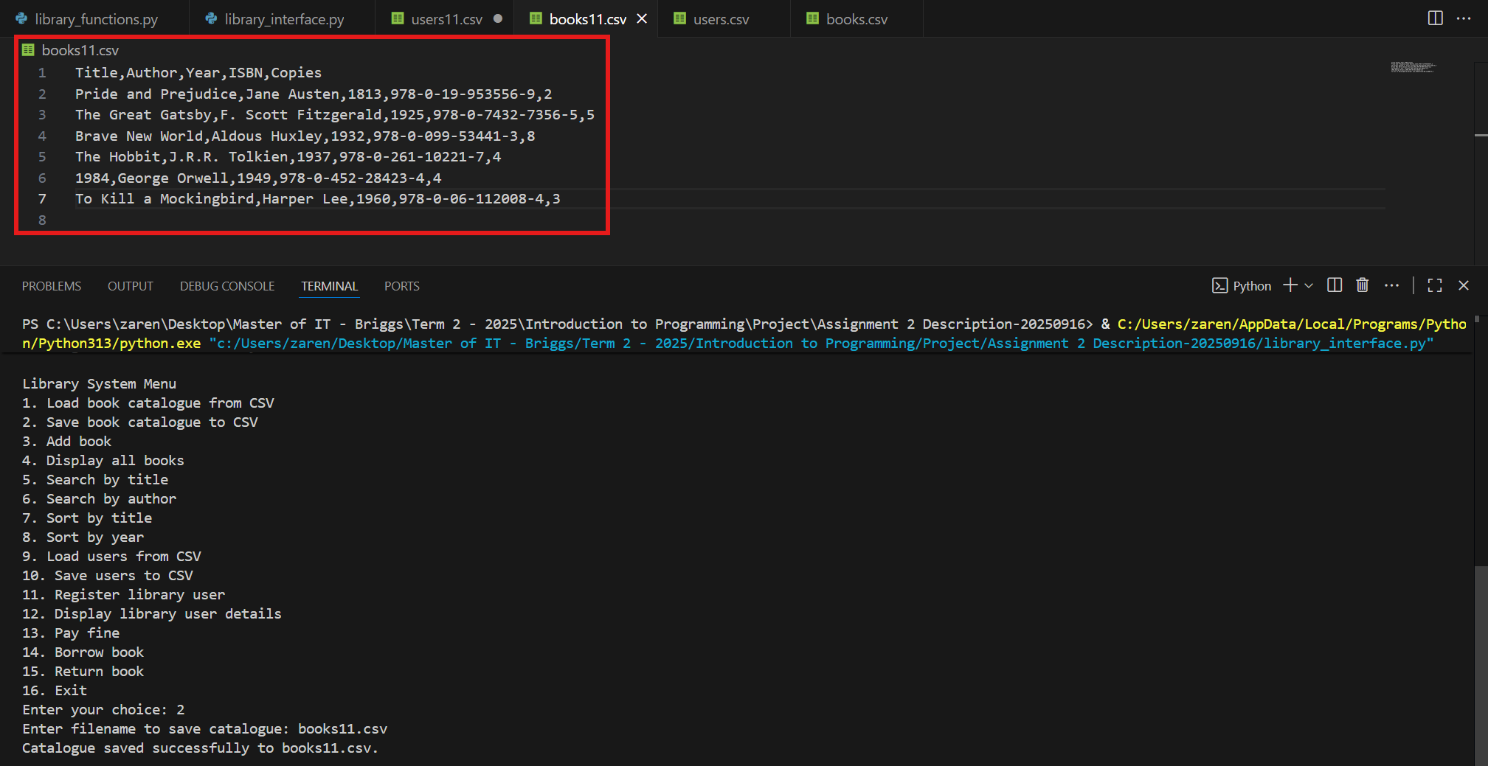
The two screenshots above show the result after executing library_interface.py, along with the before-and-after view of the books11.csv file. In the first screenshot, the file books.csv was loaded so that the variable catalogue contained data. In the second screenshot, the catalogue was saved to books11.csv by selecting option 2 and entering the filename books11.csv. After this, the program displayed the confirmation message: “Catalogue saved successfully to books11.csv”.
The highlighted red box shows the changes in the contents of books11.csv. By comparing the two screenshots, it can be seen how the data was successfully written to the new file.

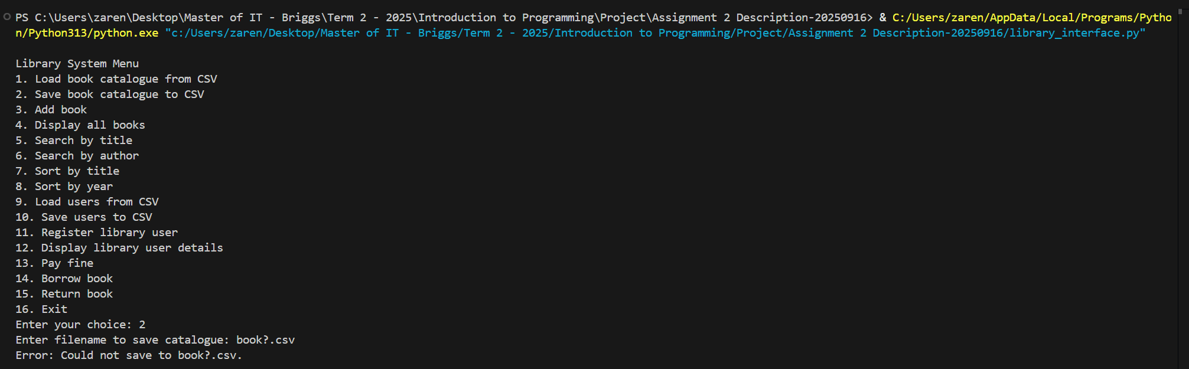
The screenshot above demonstrates the error handling for an OSError. In this example, the file was named book?.csv, which is invalid in Windows filenames. As a result, the program was unable to create the file and triggered the error handling.
3. def add_book(catalogue, title, author, year, isbn, copies) -> None
# Adds the record of a new book to the catalogue.
Answer:
def add_book(catalogue: List[dict], title: str, author: str, year: int, isbn: str, copies: int) -> None:
"""
Add a new book record to the catalogue.

Args:
catalogue (List[dict]): The list of existing book dictionaries.
title (str): The title of the book.
author (str): The author of the book.
year (int): The publication year of the book.
isbn (str): The ISBN identifier of the book.
copies (int): The number of copies available.

Returns:
None

Raises:
None
"""
book = {
"Title": title,
"Author": author,
"Year": int(year),
"ISBN": isbn,
"Copies": int(copies)
}
catalogue.append(book)
print("Book added successfully to catalogue!")

Explanation:
The function add_book() is used to add a new book record to the catalogue. It accepts six parameters: catalogue (a list of existing book dictionaries), title, author, year, isbn, and copies. The parameters title, author, and isbn are strings, while year and copies are expected to be integers.
The function begins by creating a dictionary named book, which stores the provided details as key, value pairs: Title, Author, Year, ISBN, and Copies. The values of year and copies are explicitly converted into integers to ensure valid numeric input. Once the dictionary is created, it is appended to the catalogue list.
As shown in the main() function of library_interface.py, clip of code below, no error handling can be applied when calling add_book() because the inputs for year and copies are immediately converted to integers using int(), which assumes that the user always provides valid numeric input. This means that if a user enters invalid data, such as letters or spaces instead of numbers, the program will raise a ValueError and crash.
elif choice == '3':
title = input("Title: ")
author = input("Author: ")
year = int(input("Year: "))
isbn = input("ISBN: ")
copies = int(input("Copies: "))

Testing:
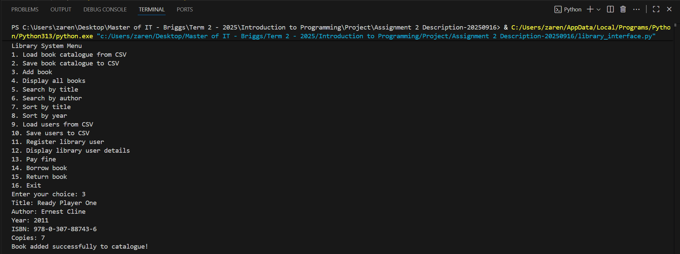
The screenshot above shows the results after executing library_interface.py and selecting option 3, where details for Title, Author, Year, ISBN, and Copies were entered. After the book details were provided, the program displayed the confirmation message: “Book added successfully to catalogue”.
4. def display_books(books_list) -> None
# Displays a list of book records (e.g., the entire catalogue or search (filtered) / sorted results)
# to the console in a tabular format, such as in the following example.
Answer:
def display_books(booklist: List[dict]) -> None:
"""
Display a list of books in a formatted table.

Args:
booklist (List[dict]): A list of book dictionaries containing
(Title, Author, Year, ISBN, Copies).

Returns:
None

Raises:
None
"""
if not booklist:
print("No books to display.")
return

print(f"{'Title':^40} {'Author':^20} {'Year':^10} {'ISBN':^20} {'Copies':^10}")
print("-" * 105)
for book in booklist:
print(f"{book['Title'][:40]:^40} "
f"{book['Author'][:20]:^20} "
f"{book['Year']:^10} "
f"{book['ISBN'][:20]:^20} "
f"{book['Copies']:^10}")

Explanation:
The function display_books() is designed to display a list of books in a formatted table. It accepts a single parameter, booklist, which is a list of dictionaries containing the fields: Title, Author, Year, ISBN, and Copies.
The function first checks if the booklist is empty. If no books are available, it prints the message: “No books to display.” and exits the function. Otherwise, it proceeds to display the records. A table header is printed with the fields centered, followed by a horizontal divider line. The function then iterates over each dictionary in booklist and prints the values of Title, Author, Year, ISBN, and Copies in a structured, column-aligned format. String slicing is used to ensure that values do not exceed the defined column width.
Testing:
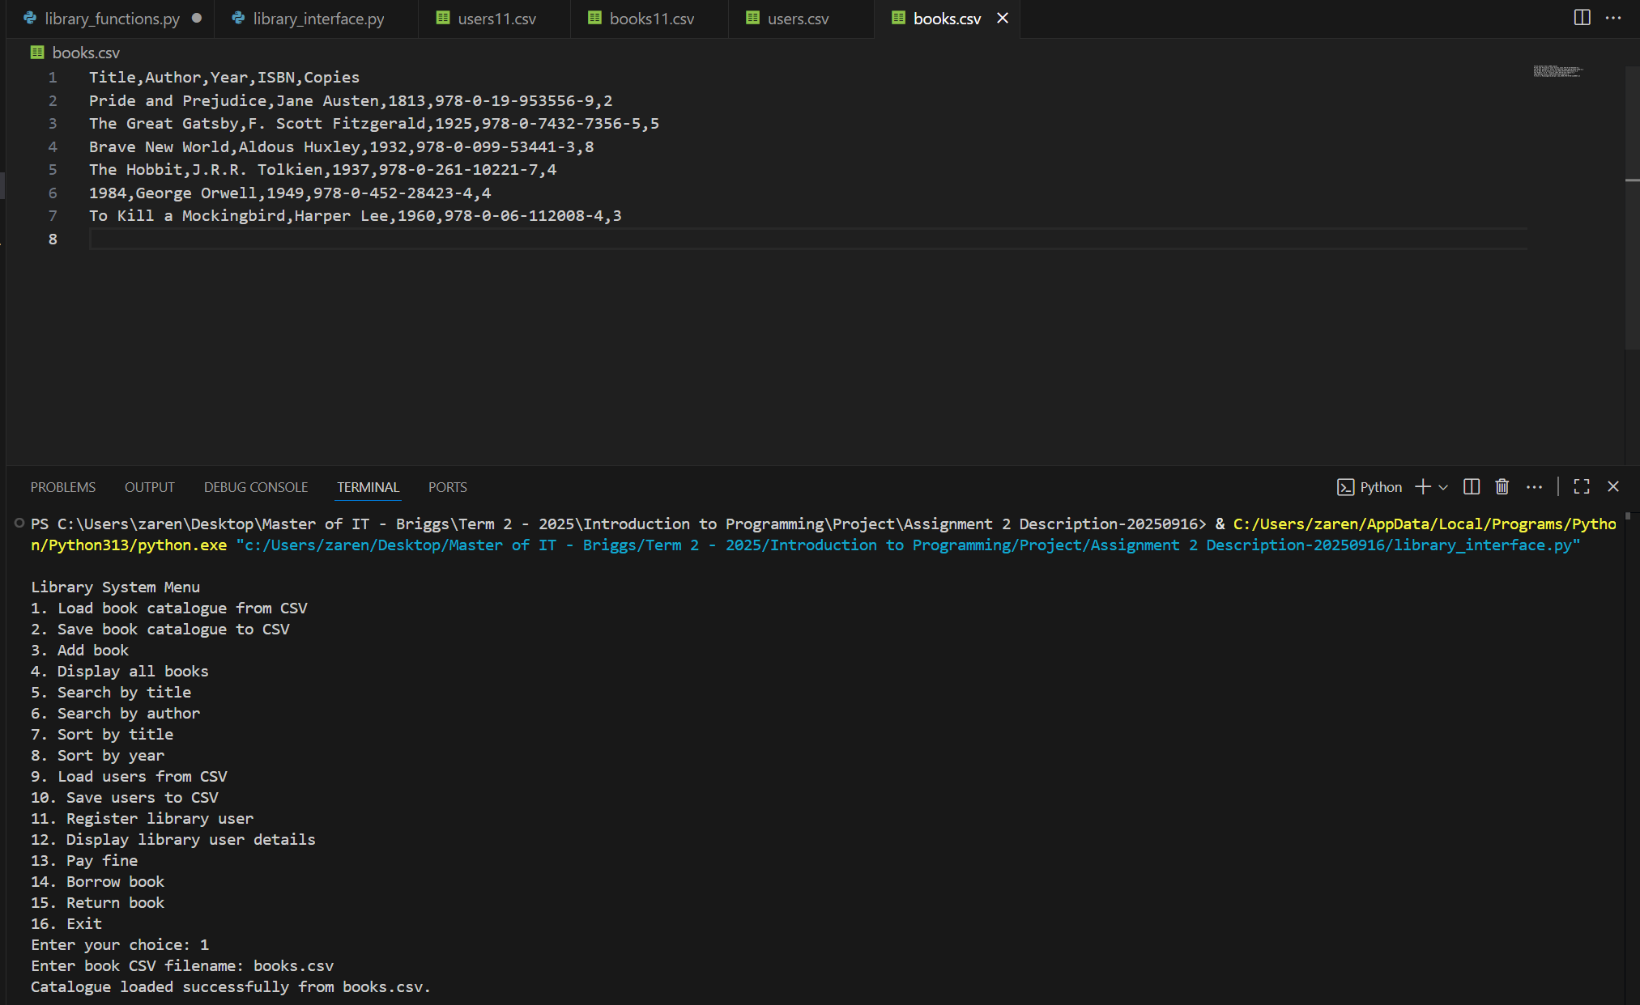
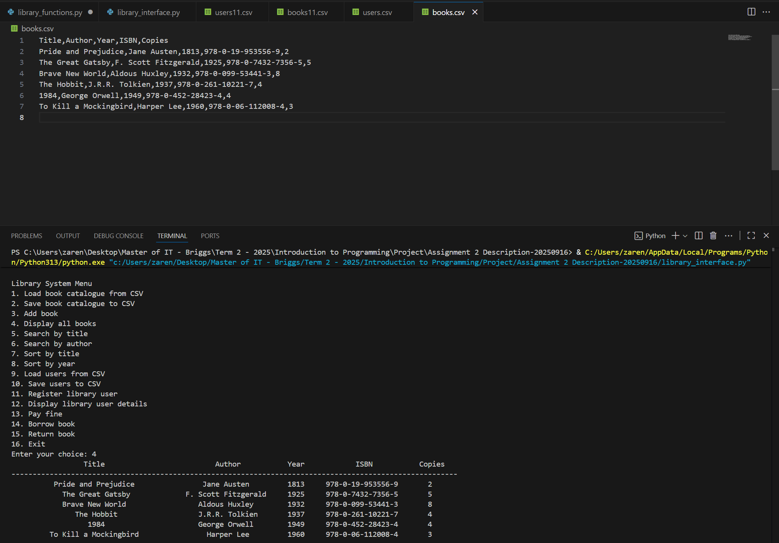
The two screenshots above show the result of executing library_interface.py, where books.csv was first loaded and then option 4 was selected. This option displays the catalogue, and the details for Title, Author, Year, ISBN, and Copies are shown in a formatted table.
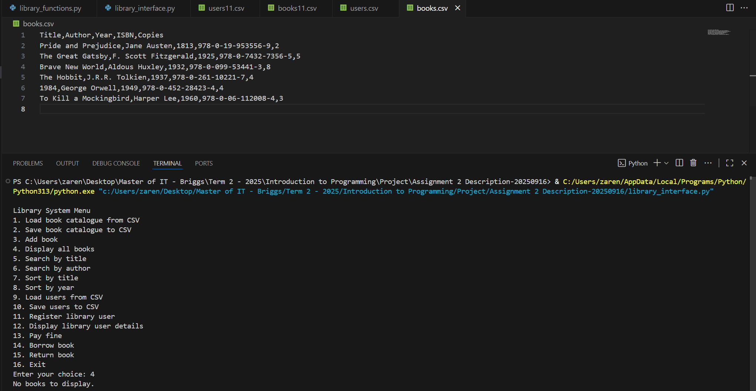
The screenshot above shows the error message: “No books to display.”, After selecting option 4, as no books are loaded in the program.
5. def search_by_title(catalogue, keyword) -> List[dict]
# Returns a list of book records whose titles match the search keyword.
Answer:
def search_by_title(catalogue: List[dict], keyword: str) -> List[dict]:
"""
Search for books in the catalogue by a keyword in the title.

Args:
catalogue (List[dict]): A list of book dictionaries containing
(Title, Author, Year, ISBN, Copies).
keyword (str): The search keyword to match against book titles
(case-insensitive).

Returns:
List[dict]: A list of book dictionaries whose titles contain
the given keyword.

Raises:
None
"""
results = []
if not keyword.strip():
print("Error: Search keyword cannot be empty or spaces only.")
return results
for book in catalogue:
if keyword.lower() in book["Title"].lower():
results.append(book)
return results

Explanation:
The function search_by_title() allows users to search for books in the catalogue by providing a keyword to match against book titles. It accepts two parameters:
- catalogue, which is a list of book dictionaries containing the fields Title, Author, Year, ISBN, and Copies.
- keyword, which is the search term provided by the user.
The function begins by checking if the keyword is empty or contains only spaces. If so, it prints the message: “Error: Search keyword cannot be empty or spaces only.” and immediately returns an empty list. Otherwise, it proceeds with the search.
For each book in the catalogue, the function performs a case-insensitive comparison by converting both the keyword and the book’s title to lowercase. If the keyword is found within the title, the book record is appended to the results list.
Error handling is not directly applied within this function, as it relies on the validity of the catalogue file that was loaded at the beginning of the program.

Testing:
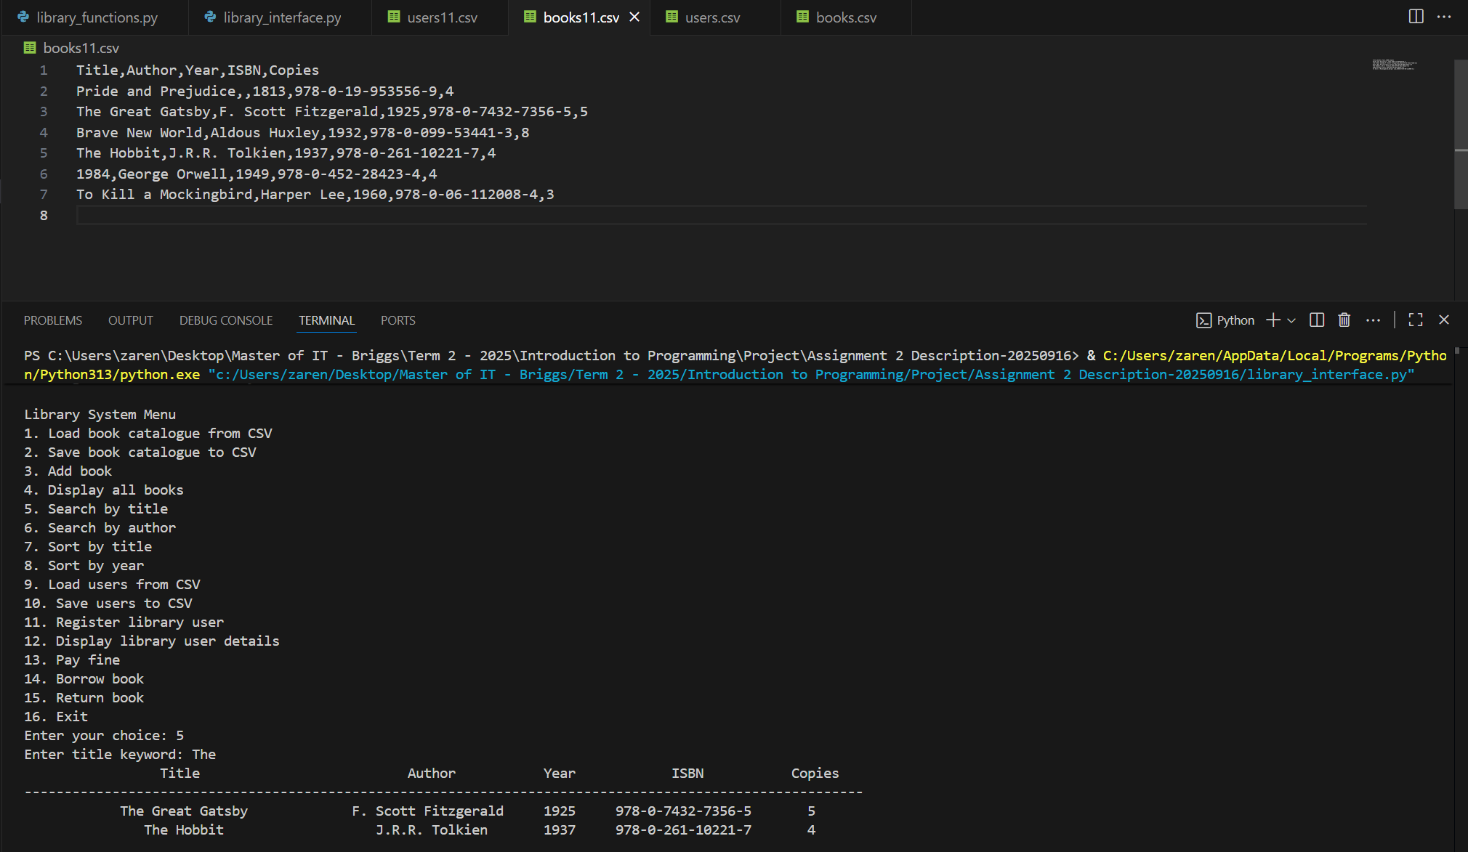
The screenshots above show the result of executing library_interface.py, where books.csv was first loaded and then option 5 was selected. This option searches the catalogue based on the user’s keyword title and displays the matching books. The details for Title, Author, Year, ISBN, and Copies are then shown in a neatly formatted table.
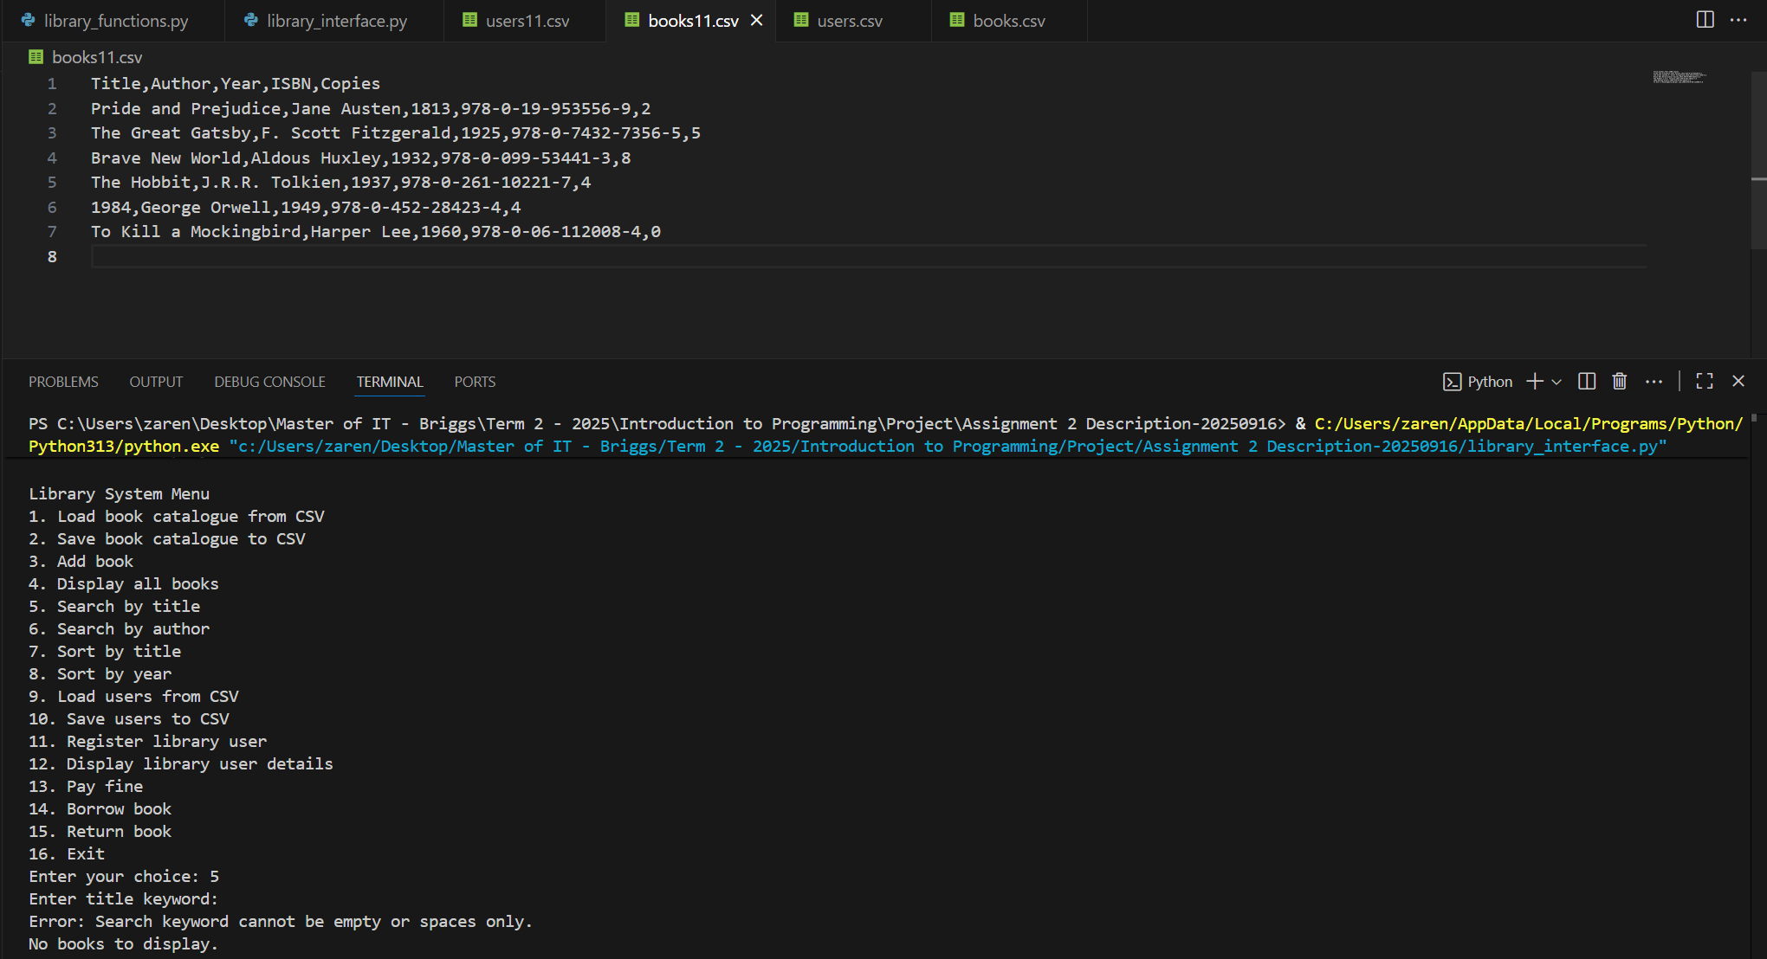
The screenshot above shows how the error message “Error: Search keyword cannot be empty or spaces only.” was triggered. This occurs when the catalogue has been loaded, but the entered author keyword is either empty or consists only of spaces.

6. def search_by_author(catalogue, author) -> List[dict]
# Returns a list of book records written by the specified author.
Answer:
def search_by_author(catalogue: List[dict], author: str) -> List[dict]:
"""
Search for books in the catalogue by a keyword in the author's name.

Args:
catalogue (List[dict]): A list of book dictionaries containing
(Title, Author, Year, ISBN, Copies).
author (str): The search keyword to match against author names
(case-insensitive).

Returns:
List[dict]: A list of book dictionaries whose authors contain
the given keyword.

Raises:
None
"""
results = []
for book in catalogue:
if not author.strip():
print("Error: Search keyword cannot be empty or spaces only.")
return results
if author.lower() in book["Author"].lower():
results.append(book)
return results

Explanation:
The function search_by_author() enables users to search for books in the catalogue by providing a keyword that matches an author’s name. It accepts two parameters:
- catalogue, which is a list of book dictionaries containing the fields Title, Author, Year, ISBN, and Copies.
- author, which is the search keyword entered by the user.
The function first checks if the author input is empty or contains only spaces. If so, it prints the message: “Error: Search keyword cannot be empty or spaces only.” and returns an empty list.
It then iterates through each book in the catalogue and performs a case-insensitive comparison by converting both the author keyword and the Author field to lowercase. If the keyword is found within the author’s name, the corresponding book record is added to the results list.
Error handling is not directly applied within this function, as it relies on the validity of the catalogue file that was loaded at the beginning of the program.
Finally, the function returns the results list, which may contain one or more matching books, or remain empty if no matches are found.

Testing:
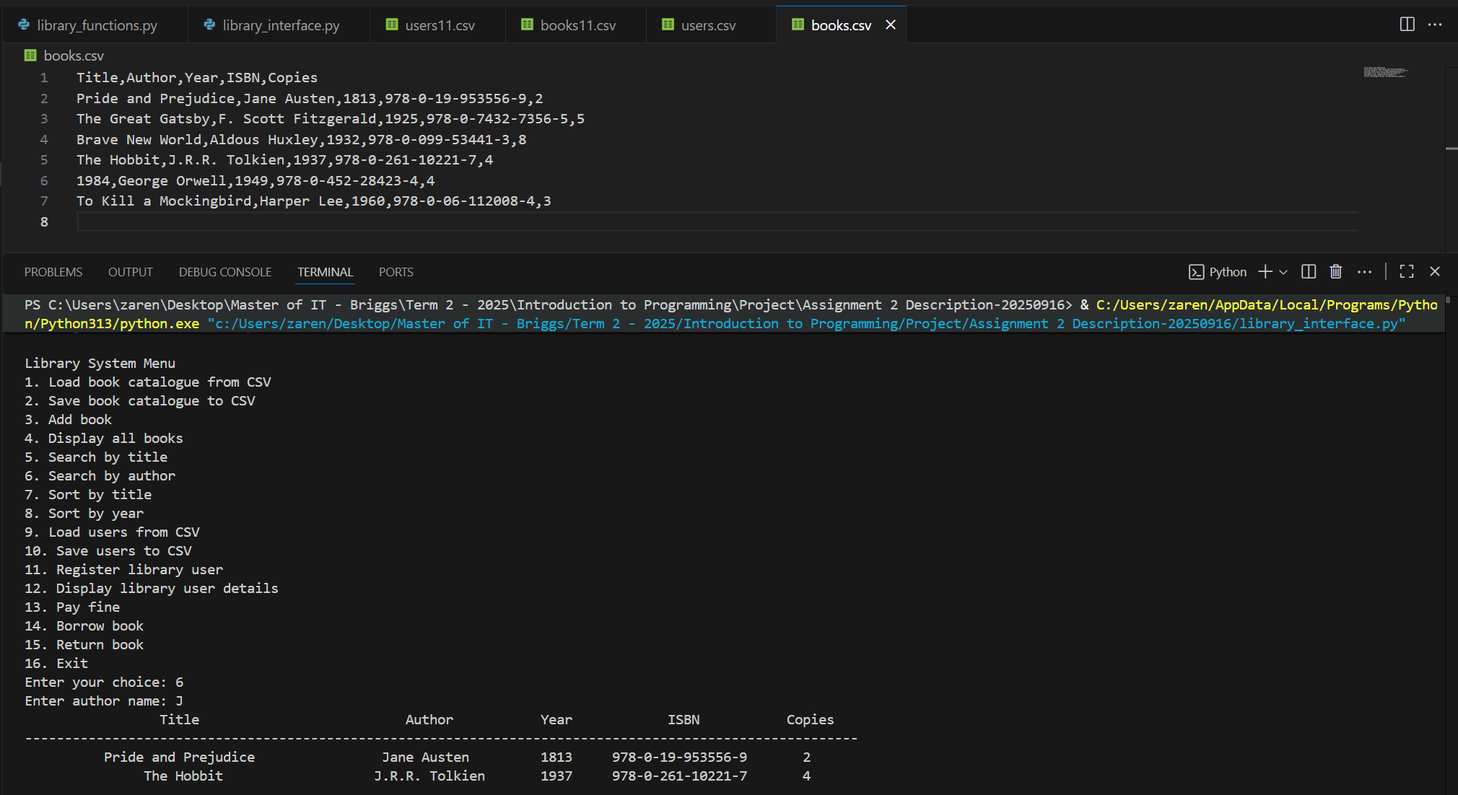
The screenshots above show the result of executing library_interface.py, where books.csv was first loaded and then option 6 was selected. This option searches the catalogue based on the user’s keyword author and displays the matching books. The details for Title, Author, Year, ISBN, and Copies are then shown in a formatted table.
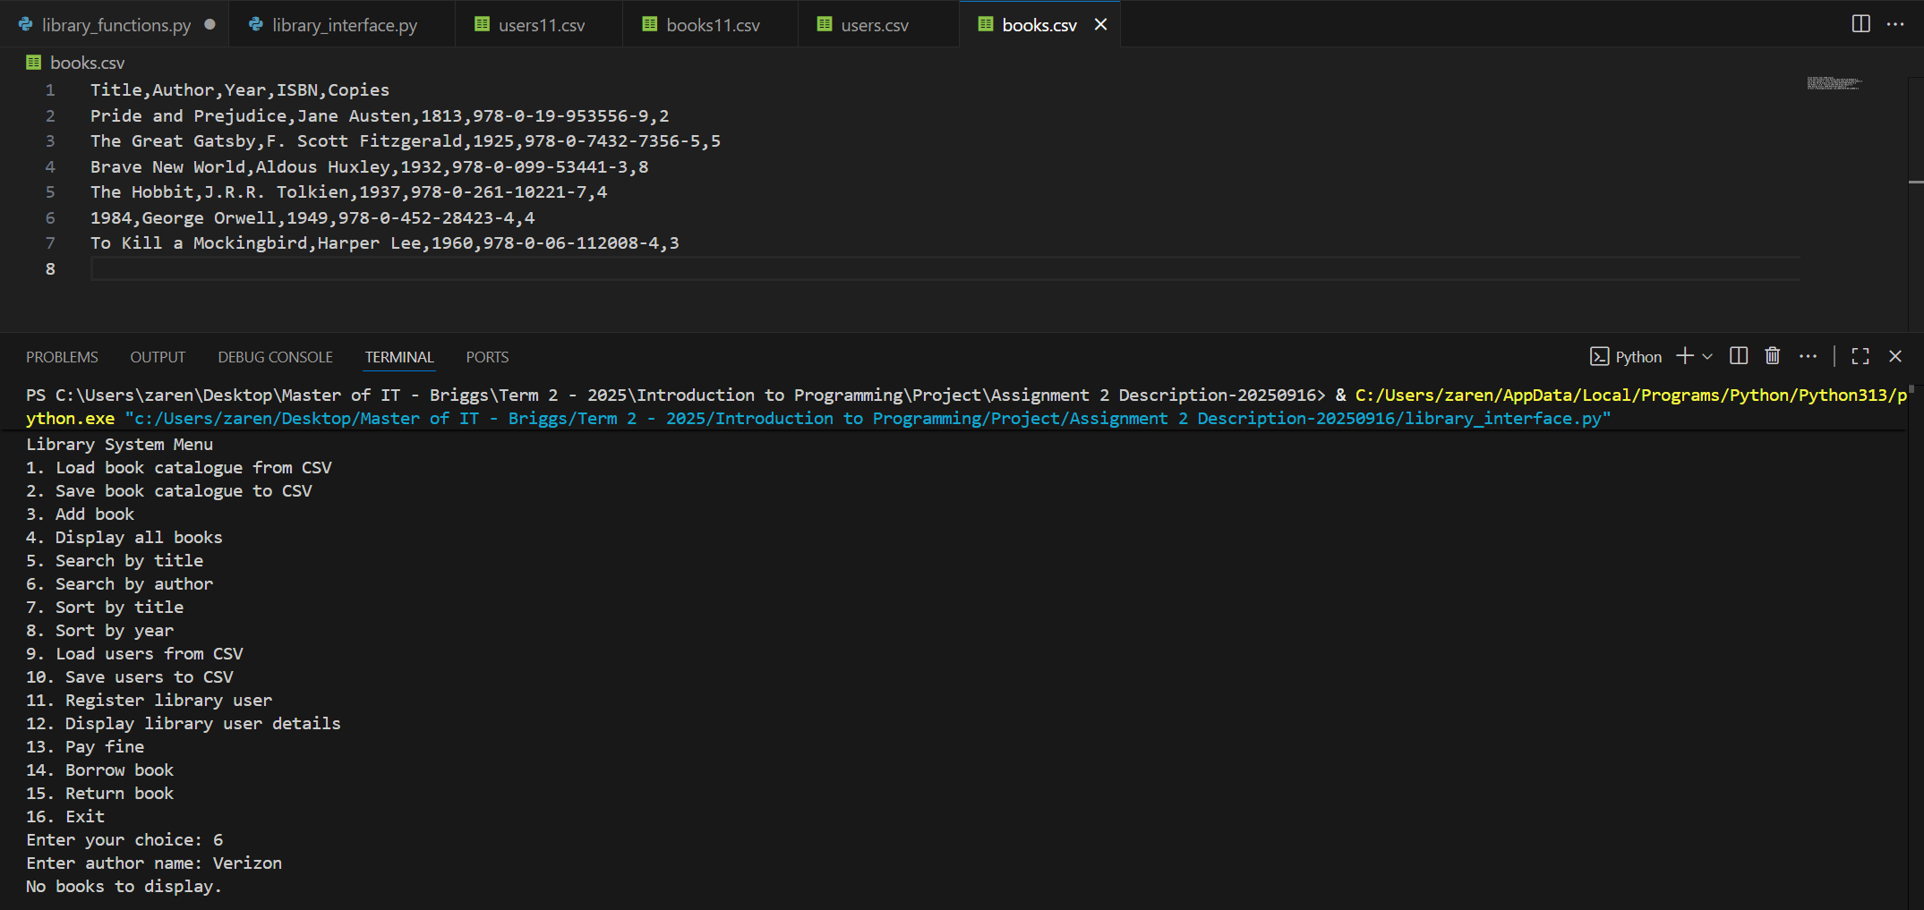
The screenshots above show the result of executing library_interface.py, where books.csv was first loaded and then option 6 was selected. It shows how error handling occurs when the user tries to search for an author that is not in the record using a keyword.
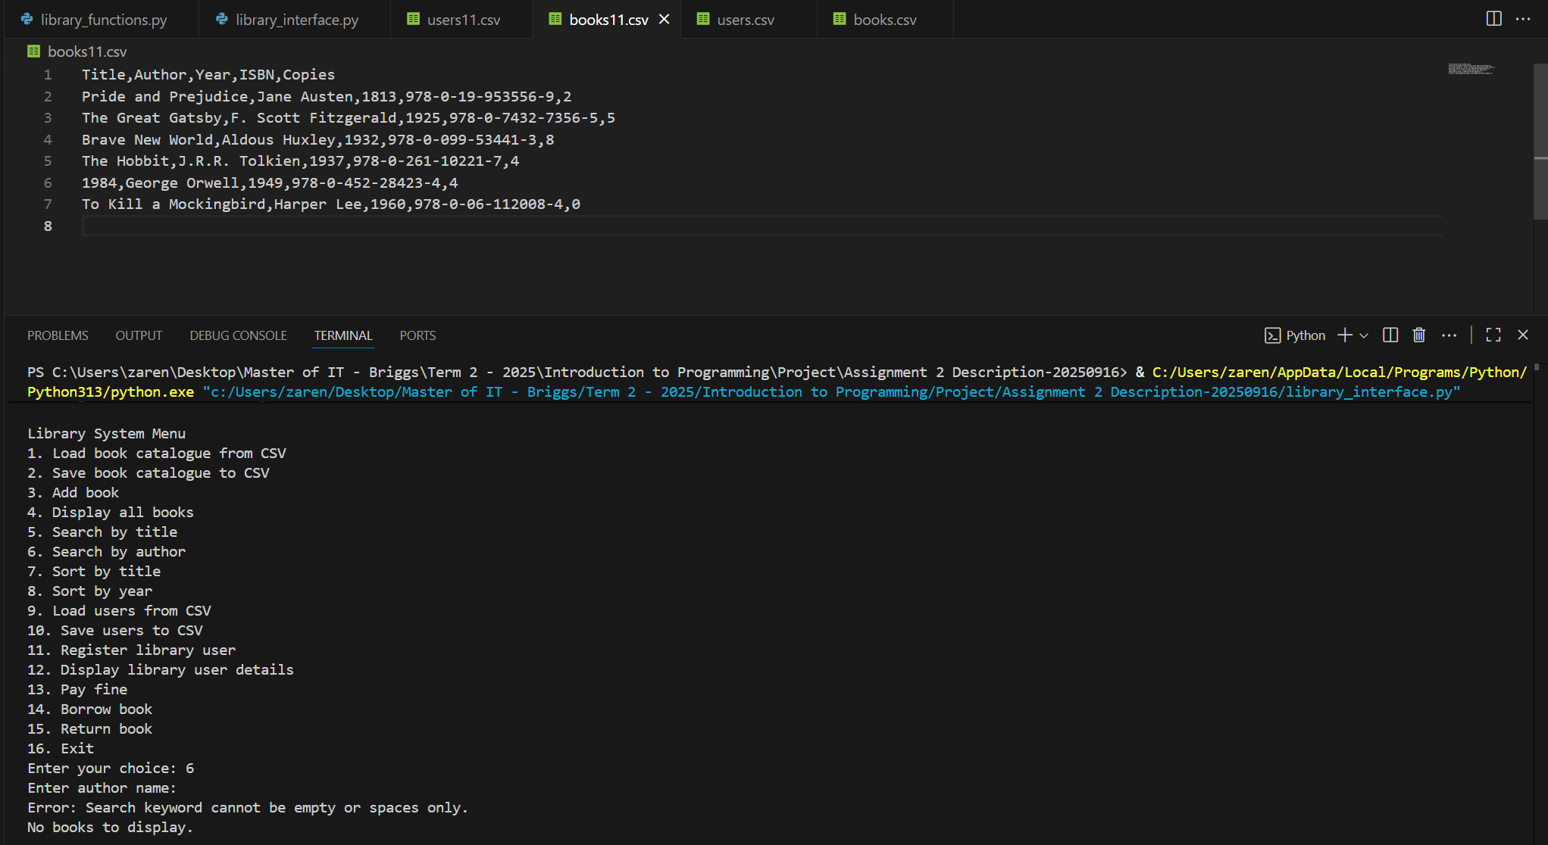
The screenshot above shows how the error message “Error: Search keyword cannot be empty or spaces only.” was triggered. This occurs when the catalogue has been loaded, but the entered author keyword is either empty or consists only of spaces.
7. def sort_by_title(catalogue) -> None
# Sorts the book catalogue alphabetically by title. The original list is modified in place.
Answer:
def sort_by_title(catalogue: List[dict]) -> None:
"""
Sort the book catalogue alphabetically by title.

Args:
catalogue (List[dict]): A list of book dictionaries containing
(Title, Author, Year, ISBN, Copies).

Returns:
None

Raises:
None
"""
catalogue.sort(key=lambda book: str(book.get("Title", "")).lower())
print("Catalogue sorted by title successfully.")

Explanation:
The function sort_by_title() is used to arrange the book catalogue in alphabetical order based on the Title field. It accepts one parameter:
- catalogue, which is a list of book dictionaries containing the fields Title, Author, Year, ISBN, and Copies.
The function applies the sort() method directly to the catalogue list. A lambda function is used as the sorting key, which retrieves the value of the Title field for each book, converts it to a string (to avoid errors if the field is missing or not a string), and then converts it to lowercase. This ensures that sorting is case-insensitive and consistent across all entries.
Once the sorting process is complete, the function prints the confirmation message:
“Catalogue sorted by title successfully.”
This function does not raise specific exceptions, but it assumes that the catalogue is a list of dictionaries with at least a Title field for proper sorting.
Testing:
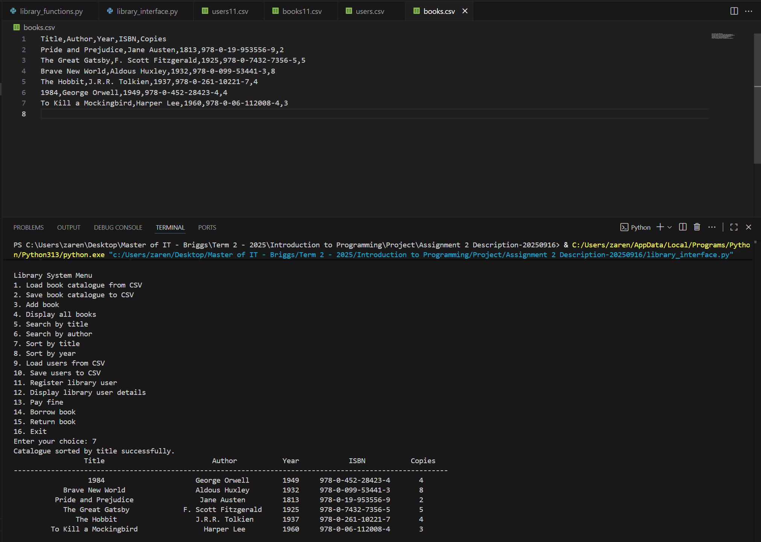
The screenshots above show the result of executing library_interface.py, where books.csv was first loaded and then option 7 was selected. This option sorts alphabetically and displays the books. The details for Title, Author, Year, ISBN, and Copies are then shown in a formatted table.
8. def sort_by_year(catalogue) -> None
# Sorts the book catalogue by publication year. The original list is modified in place.
Answer:
def sort_by_year(catalogue: List[dict]) -> None:
"""
Sort the book catalogue alphabetically by title.

Args:
catalogue (List[dict]): A list of book dictionaries containing
(Title, Author, Year, ISBN, Copies).

Returns:
None

Raises:
None
"""
catalogue.sort(key=lambda book: int(book.get("Year", 0)))
print("Catalogue sorted by year successfully.")

Explanation:
The function sort_by_year() is used to arrange the book catalogue in ascending order based on the Year field. It accepts one parameter:
- catalogue, which is a list of book dictionaries containing the fields Title, Author, Year, ISBN, and Copies.
The function applies the sort() method directly to the catalogue list. A lambda function is used as the sorting key, which retrieves the value of the Year field for each book and converts it into an integer. This ensures that sorting is performed numerically, allowing books to be ordered in order from the earliest to the most recent year. After the sorting process is completed, the function prints the confirmation message: “Catalogue sorted by year successfully.”
This function does not raise specific exceptions, but it assumes that the catalogue is a list of dictionaries where each record includes a valid Year value that can be converted into an integer.
Testing:
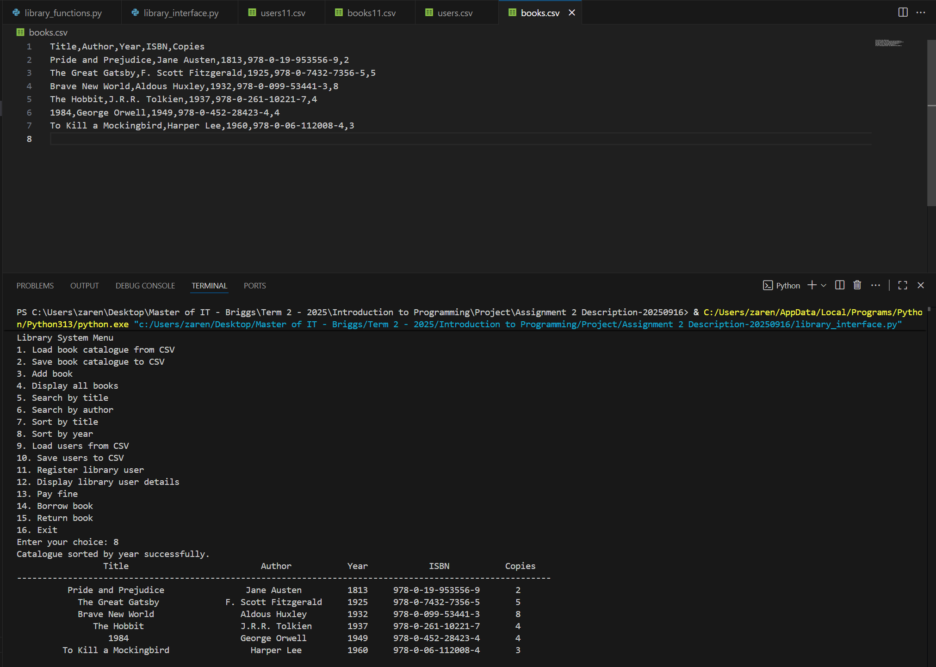
The screenshots above show the result of executing library_interface.py, where books.csv was first loaded and then option 8 was selected. This option sorts by publication year and displays the books. The details for Title, Author, Year, ISBN, and Copies are then shown in a formatted table.

Phase-2: Implement Library User Management Tasks
- Data Structure: Manage library users as a list of dictionaries of user records. To see how a User Record should look like, refer to the attributes provided under Library Users above.
- Core functions are outlined below:
1. def load_users(csv_filename) -> List[dict]
# Loads user records from a CSV file. # Returns the user records as a list of dictionaries.
Answer:
def load_users(filename: str) -> List[dict]:
"""
Load user records from a CSV file.

Args:
filename (str): The CSV file containing user records with fields
(ID, Name, Email, Address, Fine, BooksBorrowed).

Returns:
List[dict]: A list of user dictionaries, where each user contains:
- ID (str): Unique user identifier.
- Name (str): Full name of the user.
- Email (str): Email address of the user.
- Address (str): Postal address of the user.
- Fine (float): Outstanding fine amount.
- BooksBorrowed (List[dict]): A list of borrowed book records with:
* Book Title (str)
* Due Date (str)

Raises:
FileNotFoundError: If the specified file does not exist.
KeyError: If required fields are missing in the CSV file.
ValueError: If 'Fine' cannot be converted to float or data is invalid.
"""
users = []
try:
with open(filename, mode="r", newline="", encoding="utf-8") as file:
reader = csv.DictReader(file)
for row in reader:
# Parse BooksBorrowed column
books_raw = row.get("BooksBorrowed", "").strip()
books_borrowed = []

if books_raw: # "1984|2025-07-15" to "{'Book Title': '1984', 'Due Date': '2025-07-15'}"
for entry in books_raw.split(";"):
entry = entry.strip()
if "|" in entry:
title, due_date = entry.split("|", 1)
books_borrowed.append({
"Book Title": title.strip(),
"Due Date": due_date.strip()
})
users.append({
"ID": row["ID"],
"Name": row["Name"],
"Email": row["Email"],
"Address": row["Address"],
"Fine": float(row.get("Fine", 0.00)),
"BooksBorrowed": books_borrowed,
})
except FileNotFoundError:
print(f"Error: {filename} not found.")
except KeyError:
print(f"Error: {filename} is not a valid user file.")
except ValueError:
print(f"Error: Invalid data format in {filename}.")
except Exception as e:
print(f"Unexpected error: {e}")
else:
print(f"Users loaded successfully from {filename}.")
return users

Explanation:
The function load_users() is designed to load user records from a CSV file. It accepts one parameter:
- filename – the name of the CSV file containing user data with the fields ID, Name, Email, Address, Fine, and BooksBorrowed.
The function begins by opening the specified file in read mode using the open() function. A DictReader object is created to read the file as a sequence of dictionaries. For each row, the function extracts the fields and processes them into a structured format.
Special handling is applied to the BooksBorrowed field. If it contains data, it is parsed by splitting entries with ; (for multiple books) and then separating the title and due date using |. Each borrowed book is stored as a dictionary containing Book Title and Due Date, and these are collected in a list.
Each user record is then stored as a dictionary with the following keys:
- ID – a unique identifier for the user.
- Name – the full name of the user.
- Email – the user’s email address.
- Address – the user’s postal address.
- Fine – the outstanding fine, converted to a float.
- BooksBorrowed – a list of dictionaries, each representing a borrowed book with its title and due date.
The function uses a try–except–else structure for error handling:
- try block – Contains the main logic for opening the file, reading its contents, parsing borrowed books, and building the users list.
- except blocks – Handle specific errors:
  - FileNotFoundError – triggered if the specified file does not exist, printing:
“Error: {filename} not found”.
  - KeyError – triggered if required fields are missing from the CSV file, printing:
“Error: {filename} is not a valid user file”.
  - ValueError – triggered if the Fine column or other data cannot be converted properly, printing:
“Error: Invalid data format in {filename}”.
  - Exception – triggered if an unexpected error occurs that isn’t covered by the other specific error types, printing:
“Unexpected error: {e}”
- else block – Executes only if no errors occur in the try block. In this case, the program prints the confirmation message:
“Users loaded successfully from {filename}”.
Finally, the function returns the variable users, which contains the list of dictionaries representing all user records.
Testing:
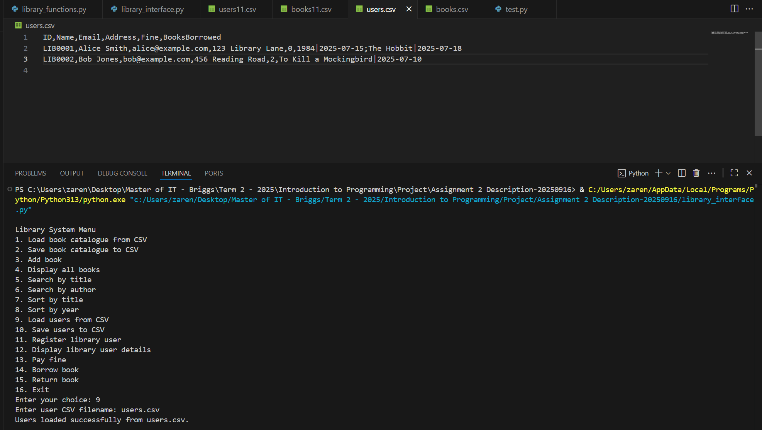
The screenshot above shows the result after executing library_interface.py, selecting option 9, and entering the filename users.csv. After this, the program displays the confirmation message: “Users loaded successfully from users.csv”.
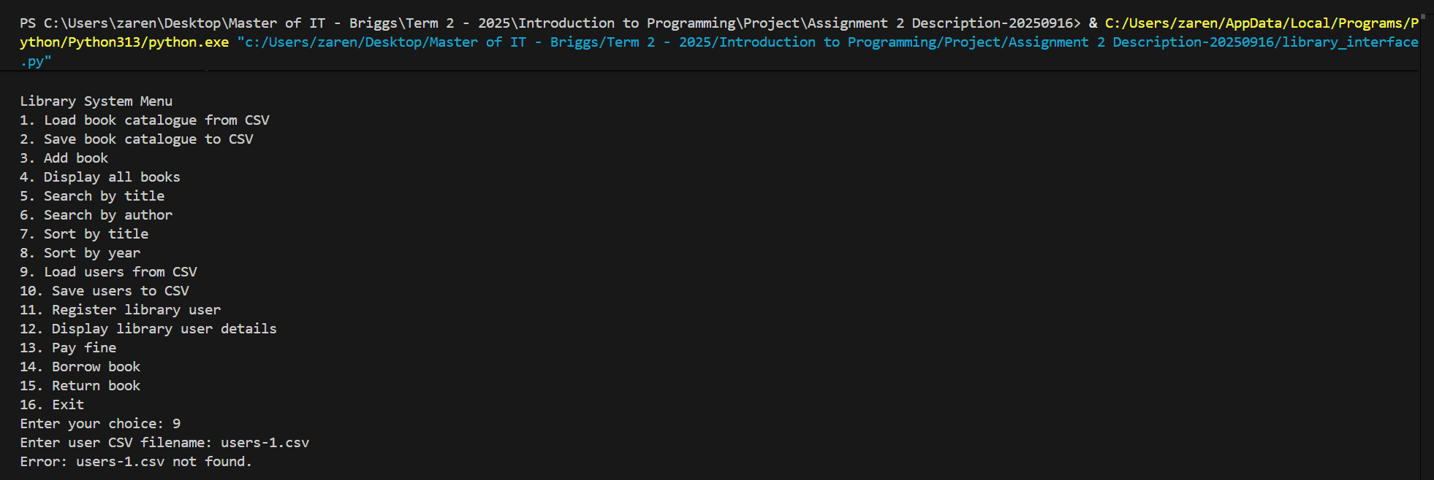
The screenshot above demonstrates how a FileNotFoundError is triggered when the user attempts to access a file that does not exist. In this case, the program could not locate the specified file and displayed the corresponding error message.
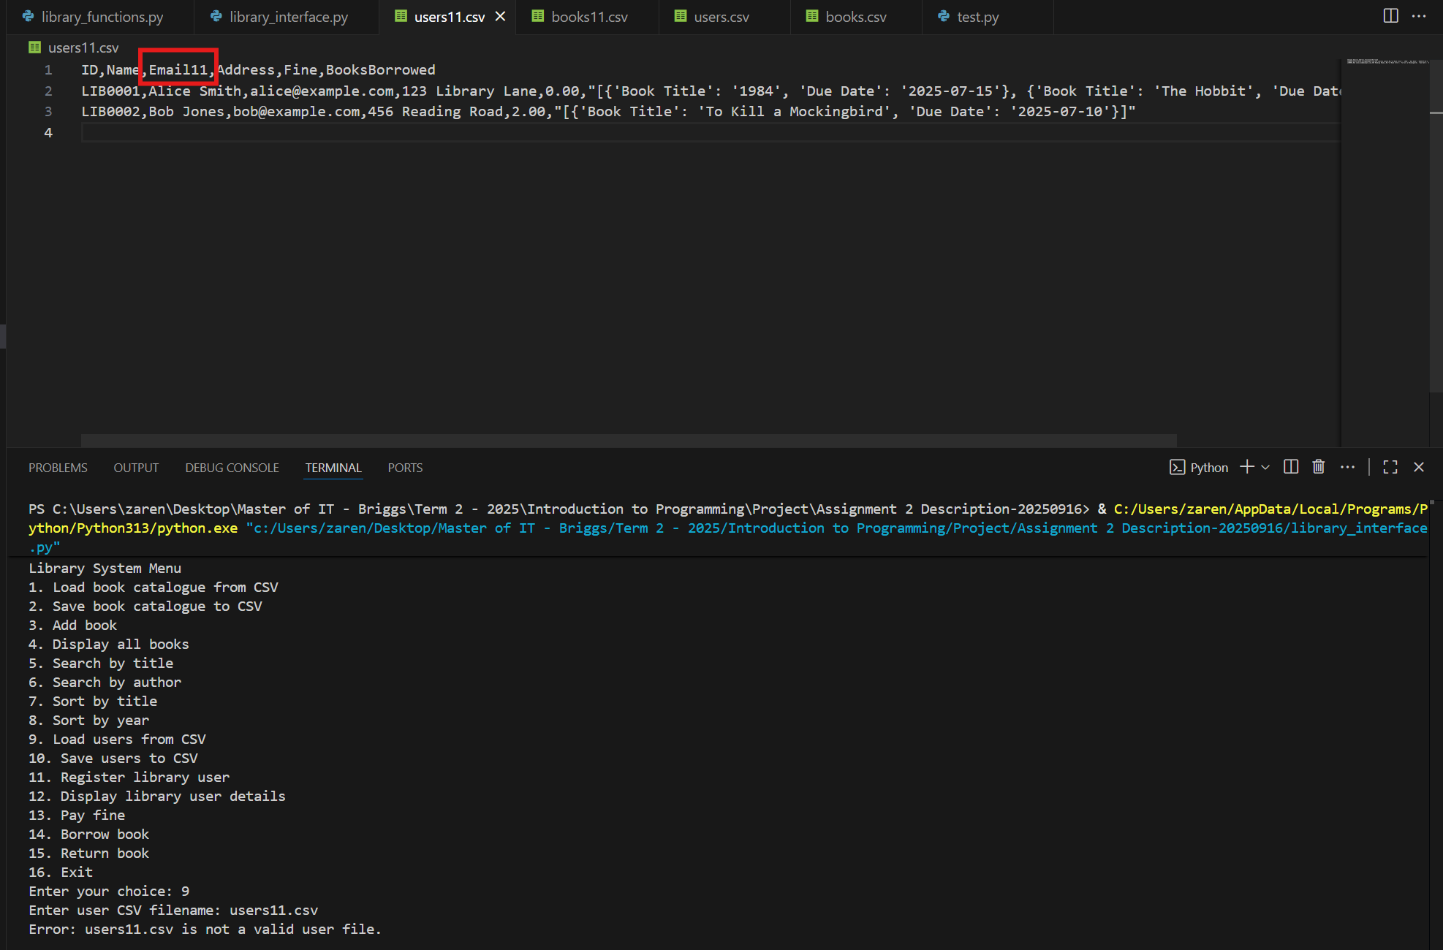
The screenshot above demonstrates how a KeyError was triggered. This occurred when the user attempted to load users11.csv, which contained an incorrect column heading, Email11, instead of the expected Email. As a result, the program was unable to match the required field and displayed the corresponding error message.

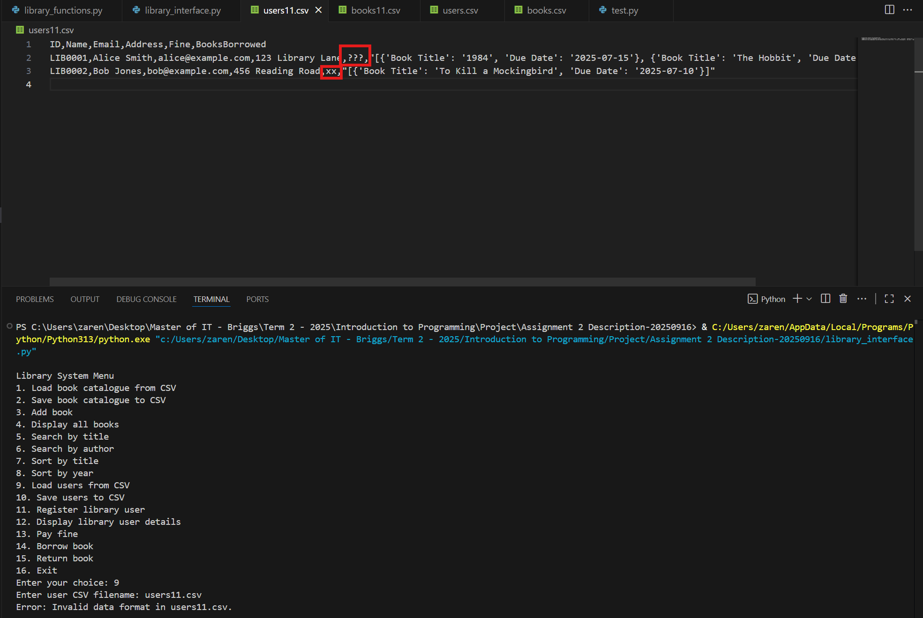
The screenshot above demonstrates how a ValueError was triggered. This occurred when the program attempted to load users11.csv, which contained invalid data in the Fine field. Since the program expects this value to be converted into a float, but instead encountered a string (e.g., "???" or "xx"), the conversion failed, and the error handler was triggered. As a result, the program displayed the message: “Error: Invalid data format in users11.csv”.

2. def save_users(filename, users) -> None
# Saves the user records to a CSV file.
Answer:
def save_users(filename: str, users: List[dict]) -> None:
"""
Save user records to a CSV file.

Args:
filename (str): The CSV file to save the user records to.
users (List[dict]): A list of user dictionaries containing:
- ID (str): Unique user identifier.
- Name (str): Full name of the user.
- Email (str): Email address of the user.
- Address (str): Postal address of the user.
- Fine (float): Outstanding fine amount (formatted to 2 decimals).
- BooksBorrowed (list): Borrowed book records.

Returns:
None

Raises:
OSError: If the file cannot be created or written to.
"""
try:
with open(filename, mode="w", newline="", encoding="utf-8") as file:
fieldnames = ["ID", "Name", "Email", "Address", "Fine", "BooksBorrowed"]
writer = csv.DictWriter(file, fieldnames=fieldnames)

writer.writeheader()
for user in users:
writer.writerow({
"ID": user["ID"],
"Name": user["Name"],
"Email": user["Email"],
"Address": user["Address"],
"Fine": f"{float(user['Fine']):.2f}",
"BooksBorrowed": user["BooksBorrowed"]
})
except OSError:
print(f"Error: Could not save to {filename}.")
else:
print(f"Users saved successfully to {filename}.")

Explanation:
The function save_users() is designed to save user records into a CSV file. It accepts two parameters:
- filename – the name of the CSV file to save the data to.
- users – a list of user dictionaries containing the fields ID, Name, Email, Address, Fine, and BooksBorrowed.
The function begins by opening the specified file in write mode using the open() function. A DictWriter object named writer is then created with the defined field names to match the structure of user records. The writeheader() method is used to insert the column headers into the file.
Next, the function iterates through the list of user dictionaries. For each user, the details are written as a row in the CSV file. The Fine field is explicitly converted into a float and formatted to two decimal places for consistency, while the BooksBorrowed field is saved as provided, which may include multiple book records.
The function applies error handling using the try–except–else structure:
- try block – Contains the main logic for creating/opening the file, writing the header, and saving user records into the CSV file.
- except block – Catches an OSError, which occurs if the file cannot be created or written to. In such cases, the program prints:
“Error: Could not save to {filename}”.
- else block – Executes only if no exceptions occur within the try block. When the file is successfully saved, the program prints the confirmation message:
“Users saved successfully to {filename}”.
Testing:
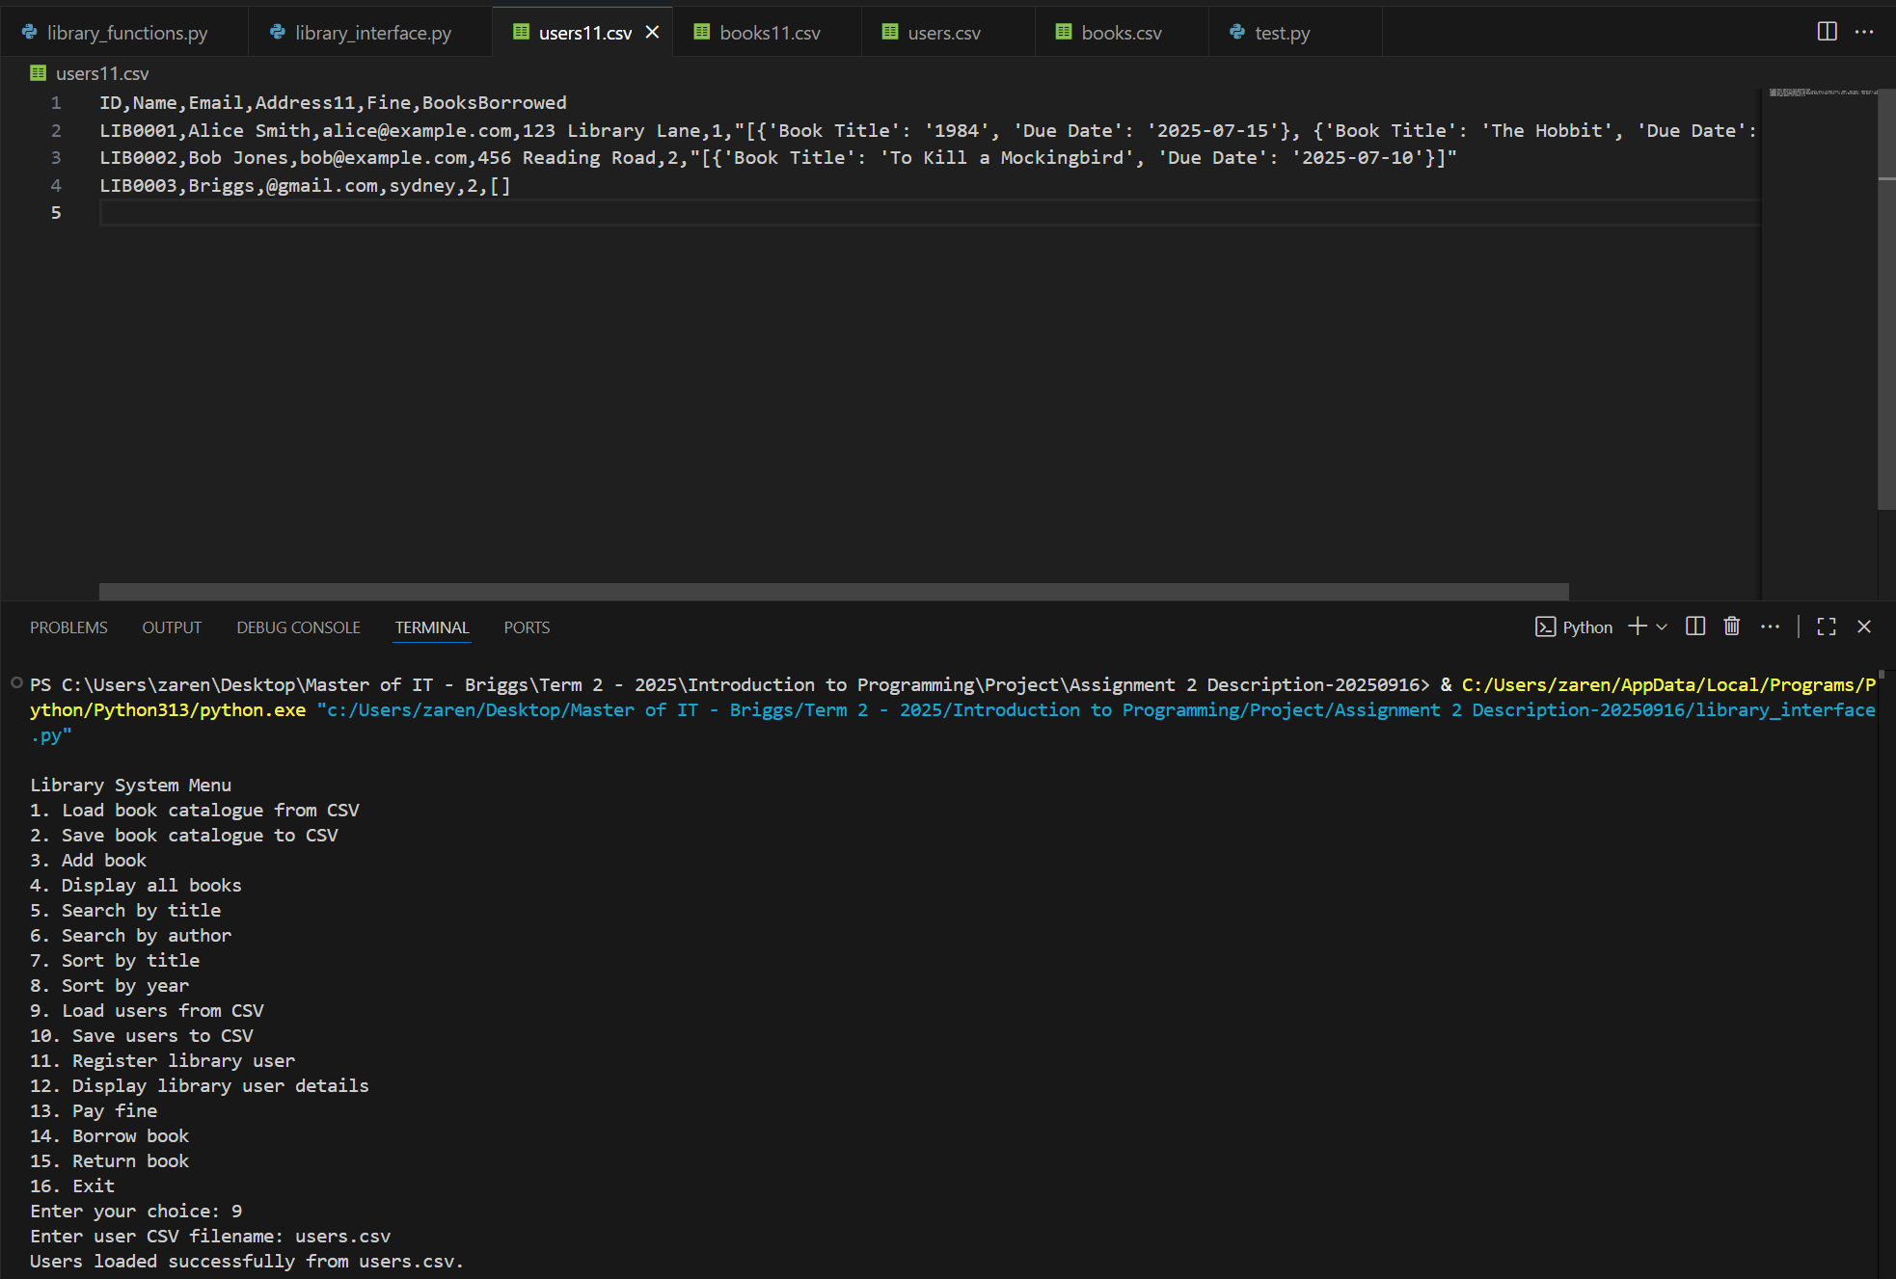
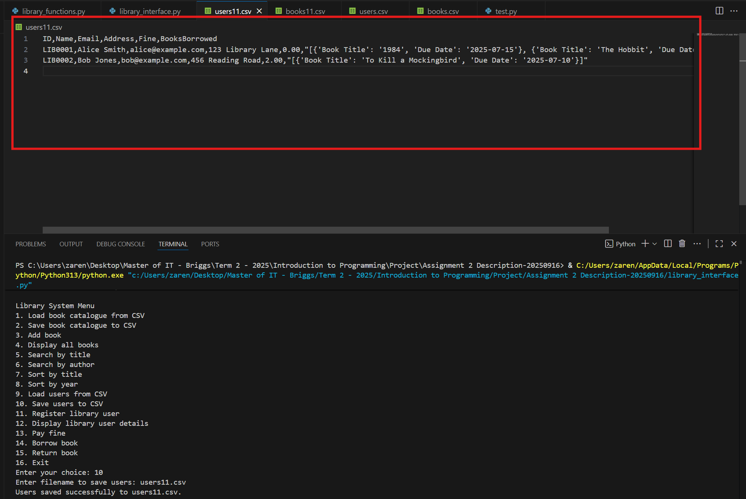
The two screenshots above show the result after executing library_interface.py, along with the before-and-after view of the users11.csv file. In the first screenshot, the file users.csv was loaded so that the variable user contained data. In the second screenshot, the variable user was saved to books11.csv by selecting option 2 and entering the filename users11.csv. After this, the program displayed the confirmation message: “Catalogue saved successfully to books11.csv”.
The highlighted red box shows the changes in the contents of users11.csv. By comparing the two screenshots, it can be seen how the data was successfully written to the new file.
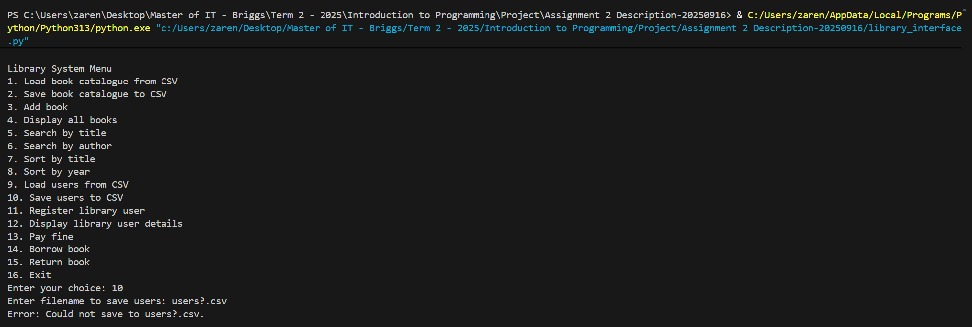
The screenshot above demonstrates how an OSError was triggered. This occurred when the program attempted to save data to a file named users?.csv. Since the question mark (?) is an invalid character in Windows filenames, the file could not be created, and the error handler was activated. As a result, the program displayed the message: “Error: Could not save to users?.csv”.

3. def register_user(users, full_name, email, address) -> str
# Registers a new library user and returns their unique User ID (as a string).
# users refer to the list of library users already registered.
# Check how many users exist when generating a new User ID.
Answer:
def register_user(users: List[dict], name: str, email: str, address: str) -> str:
"""
Register a new user and assign a unique library ID.

Args:
users (List[dict]): The list of existing user dictionaries.
name (str): Full name of the new user.
email (str): Email address of the new user.
address (str): Postal address of the new user.

Returns:
str: The newly assigned user ID in the format "LIBXXXX"
(e.g., LIB0001, LIB0002).

Raises:
OSError: If the file cannot be created or written to.
"""
if not users:
next_id_num = 1
else:
existing_ids = [int(u["ID"].replace("LIB", "")) for u in users if u["ID"].startswith("LIB")]
if existing_ids: # Checker if not empty
next_id_num = max(existing_ids) + 1
else:
next_id_num = 1

user_id = f"LIB{next_id_num:04d}"
new_user = {
"ID": user_id,
"Name": name.strip(),
"Email": email.strip(),
"Address": address.strip(),
"Fine": 0.0,
"BooksBorrowed": []
}

users.append(new_user)
print(f"User registered successfully with ID: {user_id}")
return user_id

Explanation:
The function register_user() is responsible for registering a new user and assigning them a unique library ID. It accepts four parameters:
- users – the list of existing user dictionaries.
- name – the full name of the new user.
- email – the email address of the new user.
- address – the postal address of the new user.
The function begins by checking if the users list is empty.
- If empty, the next ID number is set to 1.
- Otherwise, it extracts all existing user IDs, removes the "LIB" prefix, and converts the numeric portion into integers. If IDs are present, the next ID number is assigned as the maximum existing value plus one; if no valid IDs are found, it defaults to 1.
A new user ID is then generated in the format "LIBXXXX", where the numeric part is padded to four digits (e.g., LIB0001, LIB0002). A dictionary is created for the new user containing:
- ID – the unique library identifier.
- Name – the user’s full name, stripped of leading and trailing spaces.
- Email – the user’s email address.
- Address – the user’s postal address.
- Fine – initialized to 0.0.
- BooksBorrowed – an empty list to store future borrowed books.
This dictionary is appended to the users list. Finally, the program prints a confirmation message: “User registered successfully with ID: {user_id}”
The function then returns the newly assigned user_id so it can be referenced in the program.
Testing:
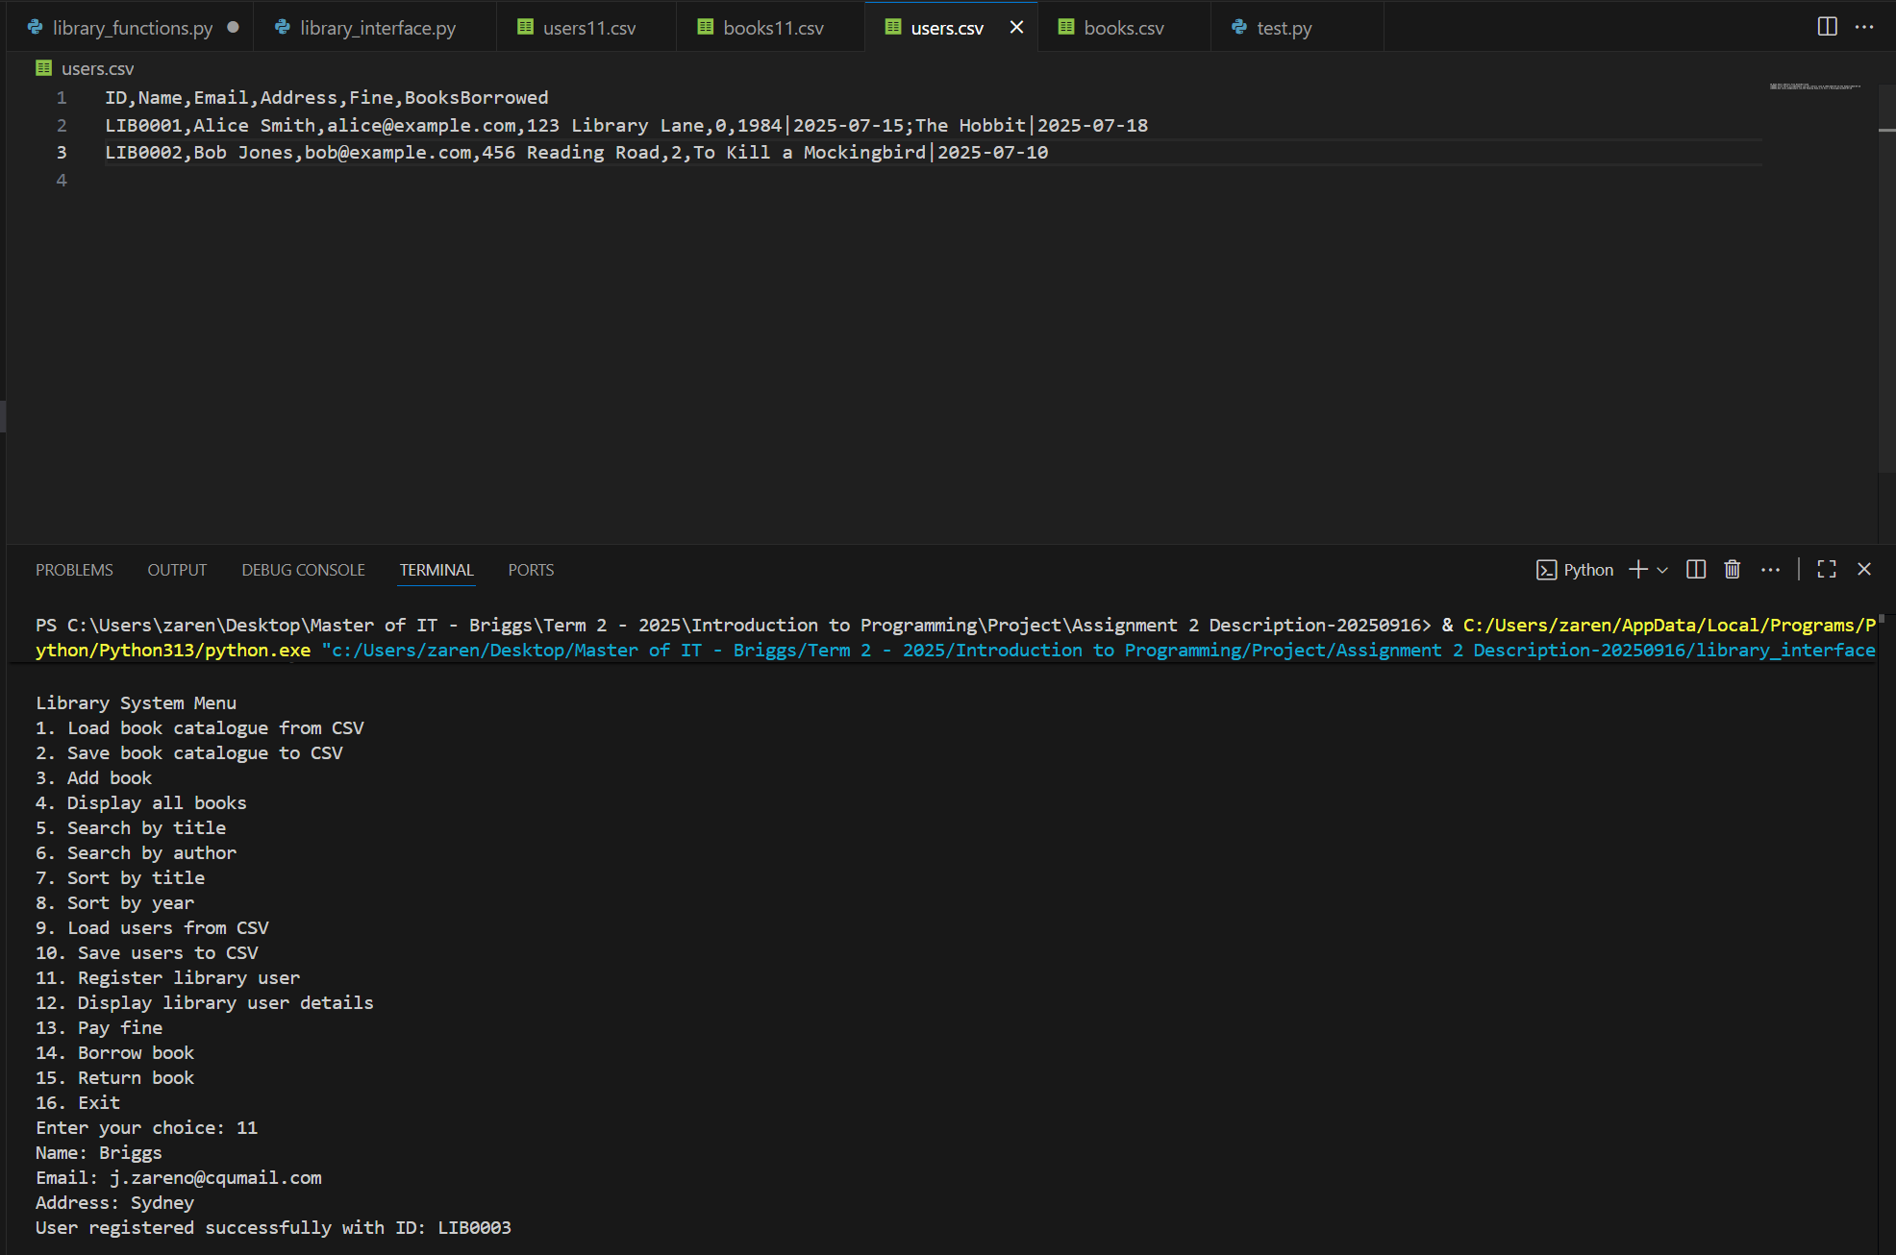
The screenshots above show the result after executing library_interface.py and selecting option 11 to register a new user (Take note: users.csv was already loaded). In this example, the details entered were Name = Briggs, Email = j.zareno@cqumail.com, and Address = Sydney. After the information was submitted, the program generated a unique ID for the new user and displayed the confirmation message: “User registered successfully with ID: LIB0003”.

4. def display_user_details(users, user_id) -> None
# Displays details of the library user identified by a user_id.
Answer:
def display_user_details(users: List[dict], user_id: str) -> None:
"""
Display the details of a specific user, including borrowed books.

Args:
users (List[dict]): A list of user dictionaries containing
(ID, Name, Email, Address, Fine, BooksBorrowed).
user_id (str): The ID of the user to display (case-insensitive).

Returns:
None

Raise:
None

Notes:
- Prints an error message if no user is found with the given ID.
- Displays borrowed books in a table format if available.
"""
# Look for the user
user = next((u for u in users if u["ID"] == user_id.upper()), None)

if not user:
print(f"Error: No user found with ID {user_id}.")
return

# Print basic details
print("\n=== User Details ===")
print(f"ID: {user['ID']}")
print(f"Name: {user['Name']}")
print(f"Email: {user['Email']}")
print(f"Address: {user['Address']}")
print(f"Outstanding Fine: ${float(user['Fine']):.2f}")

# Print borrowed books in table format
if not user["BooksBorrowed"]:
print("Books Borrowed: None")
else:
print("\nBooks Borrowed:")
print(f"{'Title':^40} {'Due Date':^15}")
print("-" * 55)

for book in user["BooksBorrowed"]:
if isinstance(book, dict):
title = book.get("Book Title", "")[:40]
due = book.get("Due Date", "")
print(f"{title:^40} {due:^15}")
else:
# if BooksBorrowed is still a raw string
print(f"{str(book):^55}")

Explanation:
The function display_user_details() is used to display the information of a specific user based on their library ID. It accepts two parameters:
- users – a list of user dictionaries containing user details.
- user_id – the unique library ID of the user to be searched (e.g., LIB0001).
The function first searches the users list using a generator expression with the next() function. It looks for the user whose ID matches the given user_id (converted to uppercase for consistency). If no user is found, the program prints an error message: “Error: No user found with ID {user_id}” and returns immediately.
If the user exists, the function prints their basic details in a clear format: ID, Name, Email, Address and Outstanding Fine (formatted to two decimal places).
The function then checks whether the user has borrowed any books:
- If no books are borrowed, it prints: “Books Borrowed: None”.
- Otherwise, it displays a table of borrowed books with two columns: Title and Due Date.
Additionally, the function includes a fallback case: if any entry in BooksBorrowed is not stored as a dictionary, it prints the raw value directly, ensuring robustness against unexpected data formats.
Testing:
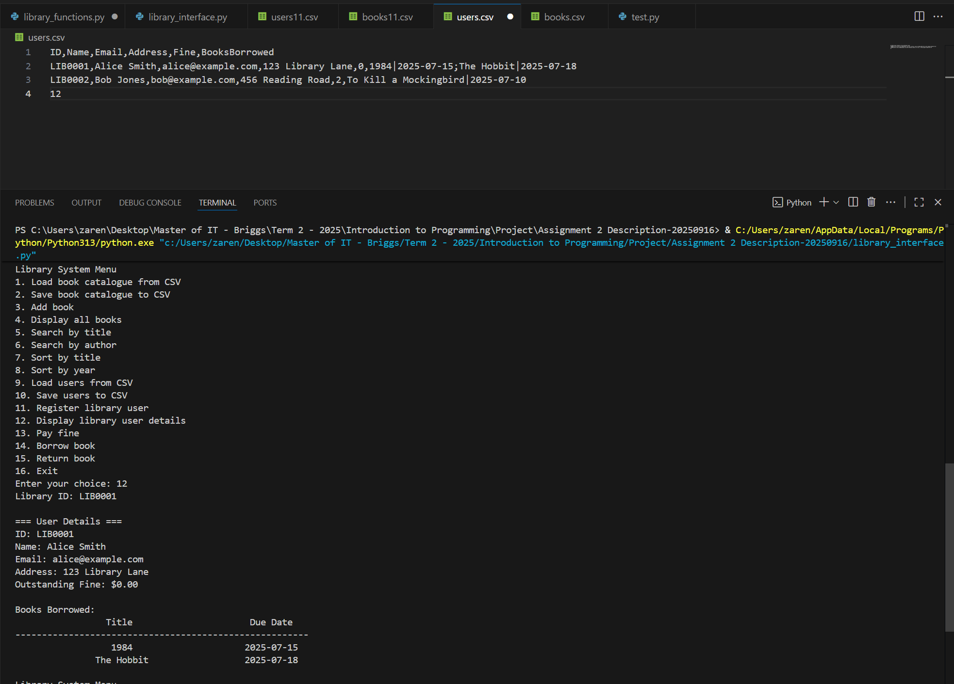

The screenshots above show the result after executing library_interface.py and selecting option 12 to display the details of a library user (note: users.csv was already loaded beforehand). In this example, the Library ID entered was LIB0001. After the input was submitted, the program displayed the user’s details, including ID, Name, Email, Address, Outstanding Fine, and a list of Books Borrowed. The borrowed books were presented in a table format showing the Title and the Due Date for return.

5. def pay_fine(users, user_id) -> None
# Resets the user's fine to zero and prints a confirmation.
Answer:
def pay_fine(users: List[dict], user_id: str) -> None:
"""
Clear the outstanding fine for a specific user.

Args:
users (List[dict]): A list of user dictionaries containing
(ID, Name, Email, Address, Fine, BooksBorrowed).
user_id (str): The ID of the user who’s fine is to be cleared.

Returns:
None

Raise:
None

Notes:
- Resets the user's fine amount to 0.0 and confirms the update.
"""
# Find the user
user = next((u for u in users if u["ID"].lower() == user_id.lower()), None)

if not user:
return

# Reset fine
user["Fine"] = 0.0
print(f"Fine for user {user['ID']} ({user['Name']}) has been cleared to $0.00.")

Explanation:
The function pay_fine() is used to clear the outstanding fine for a specific user. It accepts two parameters:
- users – a list of user dictionaries containing the fields ID, Name, Email, Address, Fine, and BooksBorrowed.
- user_id – the unique ID of the user’s fine (to be cleared).
The function begins by searching the users list for the matching user ID using a generator expression with the next() function. If no user is found with the given ID, the program does not proceed with clearing a fine. Instead, control returns to the main menu in library_interface.py, where the error is handled. At that point, the display_user_details() function prints the message:“Error: No user found with ID {user_id}”
If the user exists, the function resets the Fine field to 0.0, effectively clearing any outstanding balance. It then prints a confirmation message showing that the fine has been successfully updated: “Fine for user LIB0001 (Alice Smith) has been cleared to $0.00.”
This ensures that fines are accurately cleared when payment is made, and users’ records are updated immediately.

Testing:
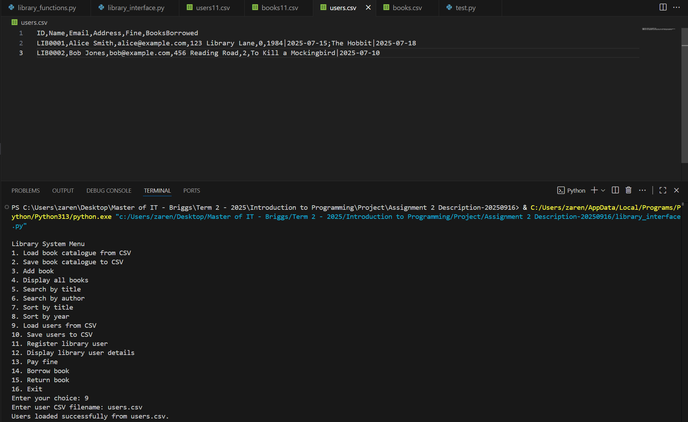
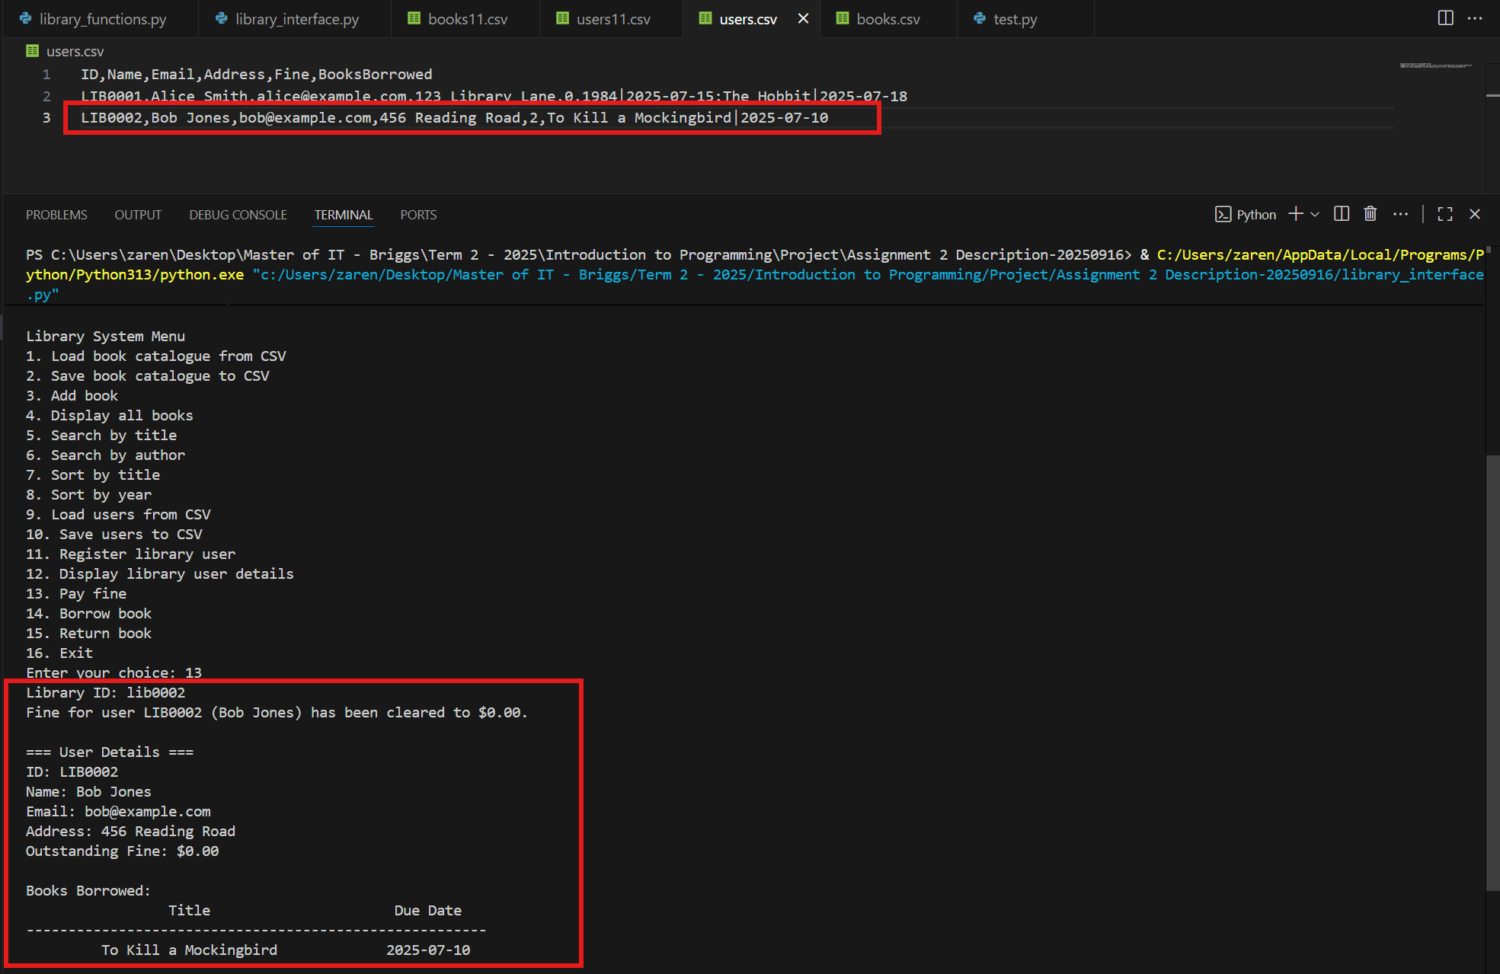
The first screenshot above shows how users.csv was loaded into the variable users by selecting option 9 from the console prompt. It also displays the contents of users.csv, which serve as a reference for verifying that the outstanding fine of the selected user will be reset to zero.
The second screenshot highlights two areas. The first highlighted box (above) points to the original record of LIB0002 in users.csv. The second highlighted box (below) shows the chosen Library ID (LIB0002) entered by the user. Directly beneath this, the program displays the confirmation message: “Fine for user LIB0002 (Bob Jones) has been cleared to $0.00.”
Afterward, the updated user details are displayed, reflecting the cleared fine.

Phase-3: Tasks related to Borrowing and Returning Books
To see how the borrowing and returning processes work, refer to the details provided under the Borrowing Process and Returning Process, above.
Core functions:
1. def borrow_book(users, catalogue, user_id, book_title)-> None
# Allows a registered user with no outstanding fines to borrow a book if a copy is available.
Answer:
def borrow_book(users: List[dict], catalogue: List[dict], user_id: str, book_title: str) -> None:
"""
Borrow a book for a user by searching titles with a keyword and update records.

Args:
users (List[dict]): A list of user dictionaries containing
(ID, Name, Email, Address, Fine, BooksBorrowed).
catalogue (List[dict]): A list of book dictionaries containing
(Title, Author, Year, ISBN, Copies).
user_id (str): The ID of the user borrowing the book (case-insensitive).
book_title (str): A non-sensitive keyword to match against book titles
(case-insensitive).

Returns:
None

Notes:
- Prints error messages for: unknown user, outstanding fines, empty keyword,
no matches, no available copies, or duplicate borrow.
- If multiple matches are found, displays a table and prompts the user to
select a book via input().
- On success, appends {"Book Title": <title>, "Due Date": <YYYY-MM-DD>}
to the user's BooksBorrowed list and decrements the book's Copies by 1.
"""
# 1. Find user
user = next((u for u in users if u.get("ID") == user_id.upper()), None)
if not user:
print(f"Error: No user found with ID {user_id.upper()}.")
return

# 2. Fine check
fine = float(user.get("Fine", 0.0))
if fine > 0.0:
print(f"Error: User {user_id.upper()} has outstanding fines (${fine:.2f}). Please pay before borrowing.")
return

# 3. Keyword search (case-insensitive)
search_term = book_title.strip().lower()
if not search_term:
print("Error: Search keyword cannot be empty.")
return

matches = [b for b in catalogue if search_term in str(b.get("Title", "")).lower()]
if not matches:
print(f"No books found for keyword: '{book_title}'.")
return

# 4. If multiple matches, show a table and prompt selection
chosen_book = None

if len(matches) == 1:
chosen_book = matches[0]

print(f"{len(matches)} match(es) found for '{book_title}':")
print(f"{'No.':^5} {'Title':^40} {'Author':^20} {'Year':^6} {'Copies':^8}")
print("-" * 85)

for i, b in enumerate(matches, start=1):
print(f"{i:^5} {str(b.get('Title',''))[:40]:^40} "
f"{str(b.get('Author',''))[:20]:^20} "
f"{str(b.get('Year','')):^6} "
f"{str(b.get('Copies','')):^8}")

if len(matches) > 1:
while True:
choice = input("Enter the No. of the book to borrow (or 0 to cancel): ").strip()
if not choice.isdigit():
print("Please enter a number.")
continue
num = int(choice)
if num == 0:
print("Borrow cancelled.")
return
if 1 <= num <= len(matches):
chosen_book = matches[num - 1]
break
print(f"Please select a number between 1 and {len(matches)}, or 0 to cancel.")

# 5. Inventory check
copies = int(chosen_book.get("Copies", 0))

if copies <= 0:
print(f"Error: No available copies of '{chosen_book.get('Title','')}'.")
return

# 6 Prevent duplicate borrow
title_lower = str(chosen_book.get("Title", "")).lower()
already_has = any(
isinstance(entry, dict) and str(entry.get("Book Title", "")).lower() == title_lower
for entry in user["BooksBorrowed"]
)
if already_has:
print(f"Error: User {user_id.upper()} already has '{chosen_book.get('Title','')}' borrowed.")
return

# 7. Compute due date
due_date = (datetime.today() + timedelta(days=14)).date().isoformat()

# 8. Update user & catalogue
user["BooksBorrowed"].append({
"Book Title": chosen_book.get("Title", ""),
"Due Date": due_date
})
chosen_book["Copies"] = copies - 1

# 9. Confirmation
print(f"'{chosen_book.get('Title','')}' borrowed by {user.get('Name','')} (ID: {user_id.upper()}). Due on {due_date}.")

The function borrow_book() is used to borrow a book for a user by searching titles with a keyword and updating the records. It accepts four arguments:
- users – a list of user dictionaries containing ID, Name, Email, Address, Fine, and BooksBorrowed.
- catalogue – a list of book dictionaries containing Title, Author, Year, ISBN, and Copies.
- user_id – the ID of the user borrowing the book, treated in a case-insensitive manner.
- book_title – a non-sensitive keyword to match against book titles, also case-insensitive.
The function begins by searching for the user using the inputted library ID. This is done with the next() function and an iterator to find the matching ID. If the Library ID is not found, the program prints the error message: “Error: No user found with ID {user_id}”
If a user is found, the function stores the record in the variable user and proceeds to the next step, which is checking the user’s outstanding fine. This is handled using the get() method, which retrieves the Fine field from the user dictionary. If no fine is found, it defaults to 0.0. If the fine has a value greater than 0.0, the function prints an error message:
“Error: User {user_id} has outstanding fines (${fine:.2f}). Please pay before borrowing.”
and then returns to the main program.
If the user has no outstanding fine, the function continues by searching for the book title entered by the user. A variable search_term is created to store the book title after removing extra spaces (strip()) and converting it to lowercase (lower()), ensuring the search is case-insensitive. A check is included to handle empty input; if the keyword is empty, the program prints: “Error: Search keyword cannot be empty.” If search_term has a value, the function proceeds by creating the variable matches, which stores any catalogue entries whose titles contain the keyword. If no matches are found, the program prints the error message: “No books found for keyword: ‘{book_title}’.” and then returns to the main() function.
If the variable matches contain one or more results, the function then checks how many books match the user’s search keyword.
First, the variable chosen_book is initialized as None. If only one match is found (len(matches) == 1), that book is automatically selected and stored in chosen_book.
Next, the program displays the total number of matches found and prints a formatted table showing the details of each matched book, including No., Title, Author, Year, and Copies. This numbering allows the user to clearly see each available option.
If more than one match exists (len(matches) > 1), the program enters a loop that prompts the user to select a book by entering its corresponding number. Several checks are performed to ensure valid input:
- If the input is not numeric, the program prints: “Please enter a number.”
- If the input is 0, the borrowing process is cancelled, and the function returns.
- If the input is within the valid range, the selected book is assigned to chosen_book and the loop breaks.
- If the input is outside the valid range, the program prints: “Please select a number between 1 and {len(matches)}, or 0 to cancel.”
A checker was also placed to check the number of copies of the book. On this part of the function, it checks the inventory of the chosen book. It retrieves the number of available copies and stores it in the variable copies. If the number of copies is less than or equal to zero, it means there are no books left to borrow. In this case, the program prints: “Error: No available copies of '{book title}'.” and exits the borrowing process.
Next, the program checks for duplicate borrowing. It compares the chosen book’s title with the titles of the books the user has already borrowed. If the user already has the same title in their BooksBorrowed list, the program prints:“Error: You have already borrowed '{book title}'.”
and stops the borrowing process.
If the user has no fine, the due date for the borrowed book will be calculated. This part of the function finalizes the borrowing process by setting a due date, updating the records, and displaying a confirmation message. The program calculates the return deadline by taking today’s date and adding 14 days using timedelta (days=14). The result is then converted into ISO format (YYYY-MM-DD) and stored in the variable due_date.
Then, the user’s record is updated by appending a dictionary to their BooksBorrowed list, containing two fields:
- Book Title – the title of the borrowed book.
- Due Date – the calculated return date.
At the same time, the catalogue record of the chosen book is updated by decreasing its Copies count by 1, reflecting that one copy has been borrowed.
Finally, the program prints a confirmation message that includes the book’s title, the user’s name and ID, and the due date. For example:
“‘1984’ borrowed by Alice Smith (ID: LIB0001). Due on 2025-10-05.”
Testing:
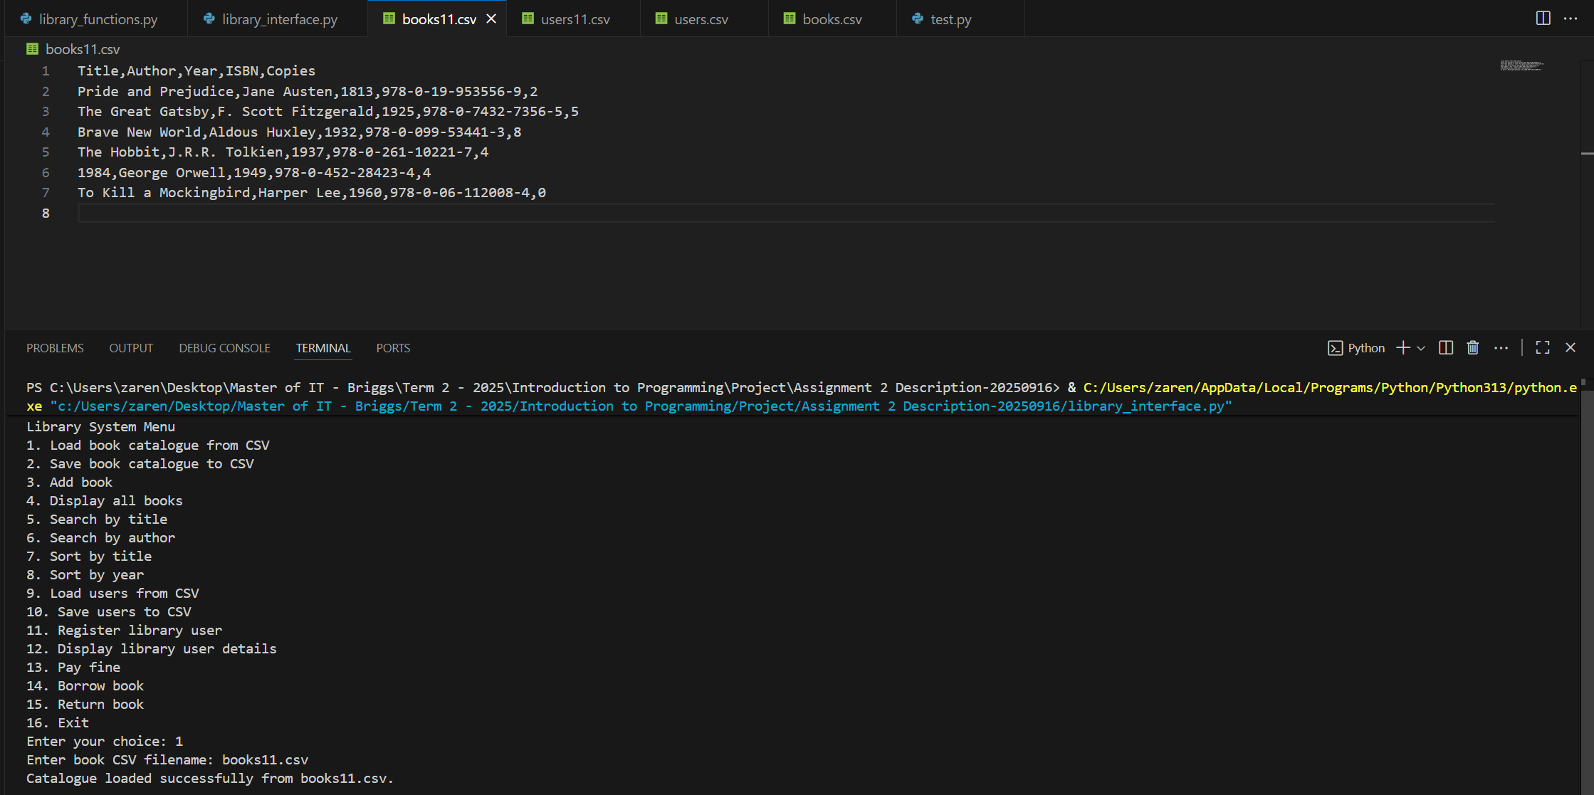
The screenshot above shows how books11.csv was loaded into the variable catalogue and its content (displayed above).
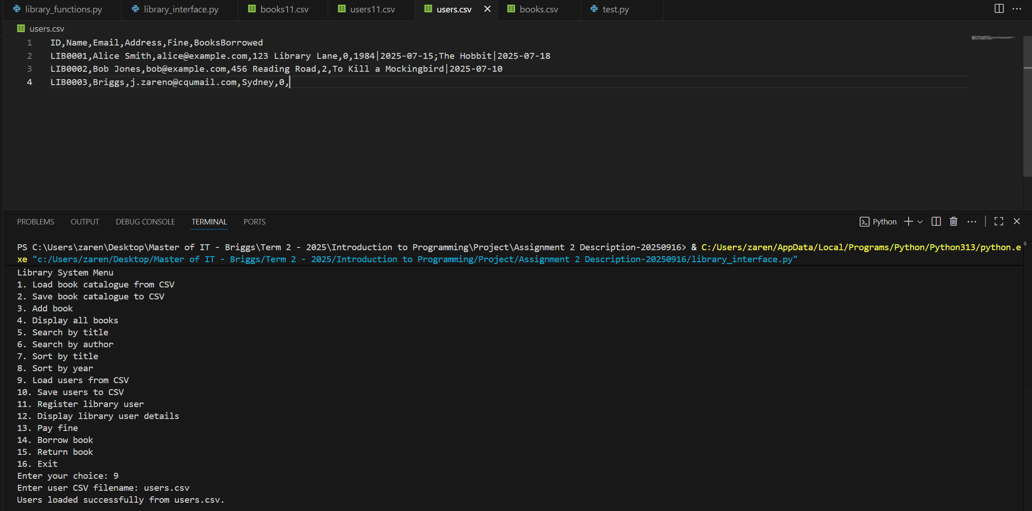
The screenshot above shows how users.csv was loaded into the variable catalogue and its content (displayed above).
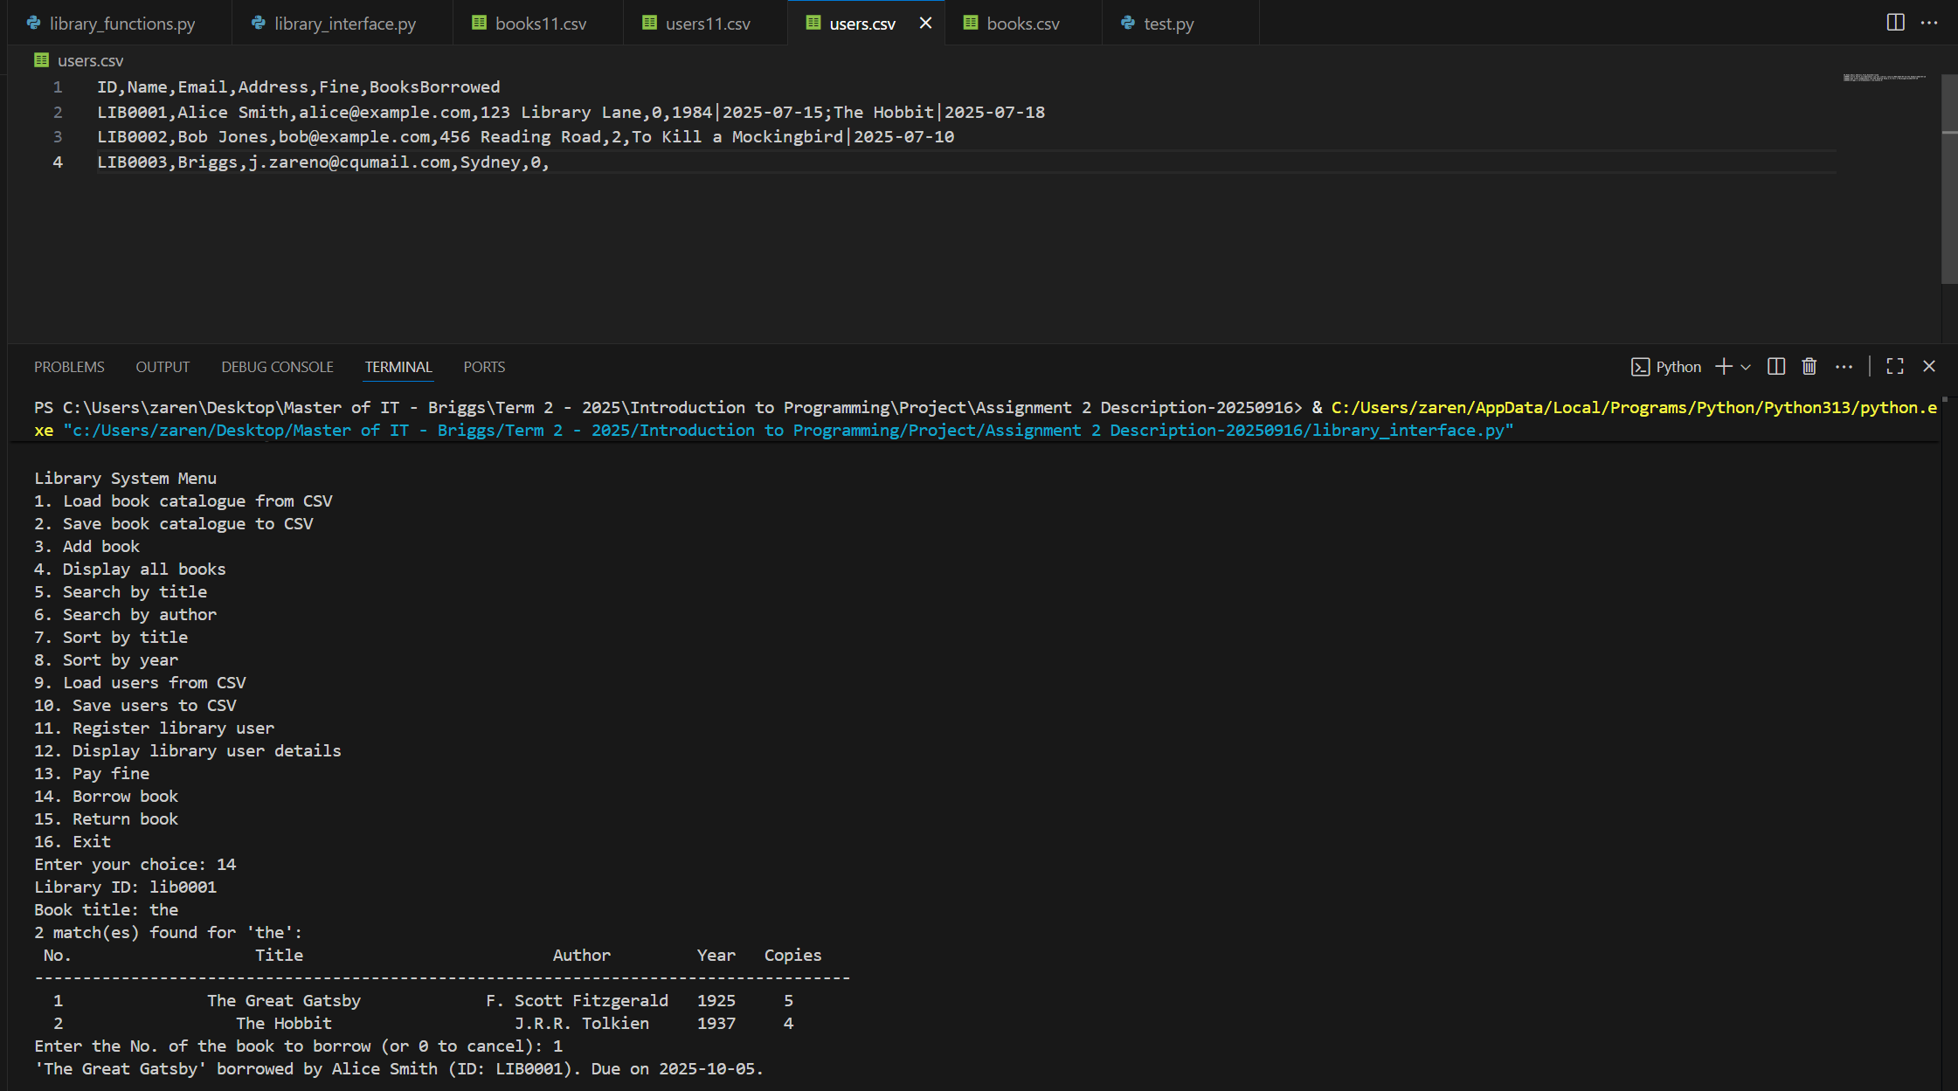
The screenshot above shows how option 14 was selected, with library ID LIB0001 and the book title keyword ‘the’ (case-insensitive input). After providing these details, the system displayed the matching books in a table format. The user was then prompted with the message: ‘Enter the No. of the book to borrow (or 0 to cancel):’. The user selected 1, choosing to borrow The Great Gatsby. A confirmation message was then displayed: ‘The Great Gatsby borrowed by Alice Smith (ID: LIB0001), due on 2025-10-05.
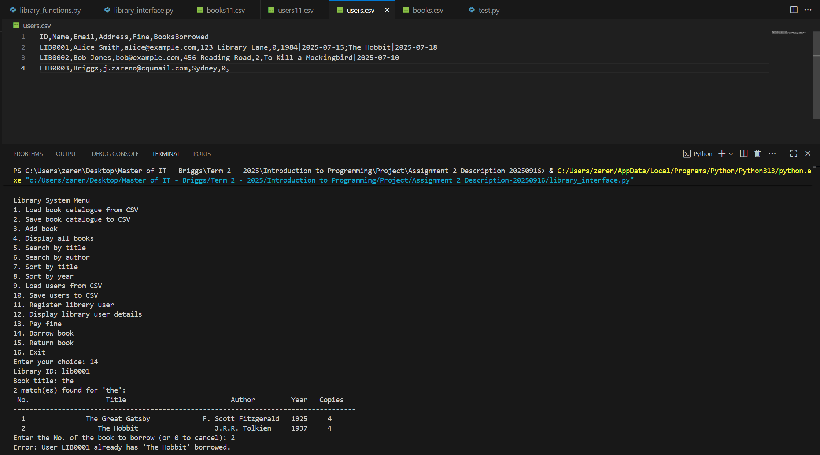
The screenshot above shows the instance when a user attempts to borrow a book that she has already borrowed previously (as recorded in the users.csv file). All book details are still displayed, but when she tries to borrow The Hobbit, the system shows an error message: ‘Error: User LIB0001 already has The Hobbit borrowed.’
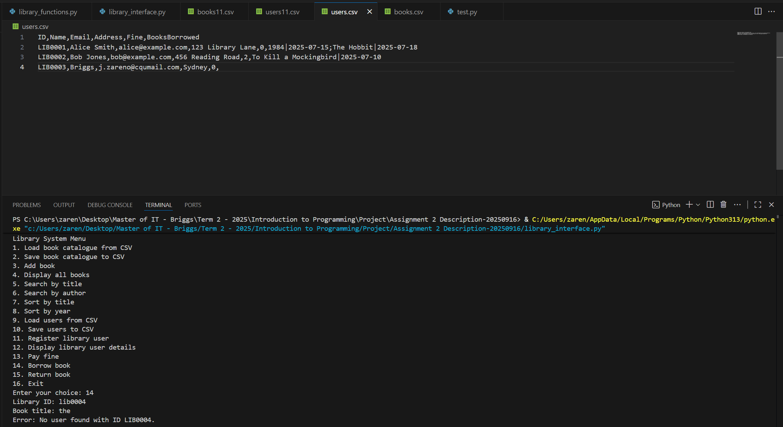
The screenshot above shows an instance where the Library ID cannot be found on the user catalogue, resulting the program printing an error message: “Error: User found with ID LIB0004”.
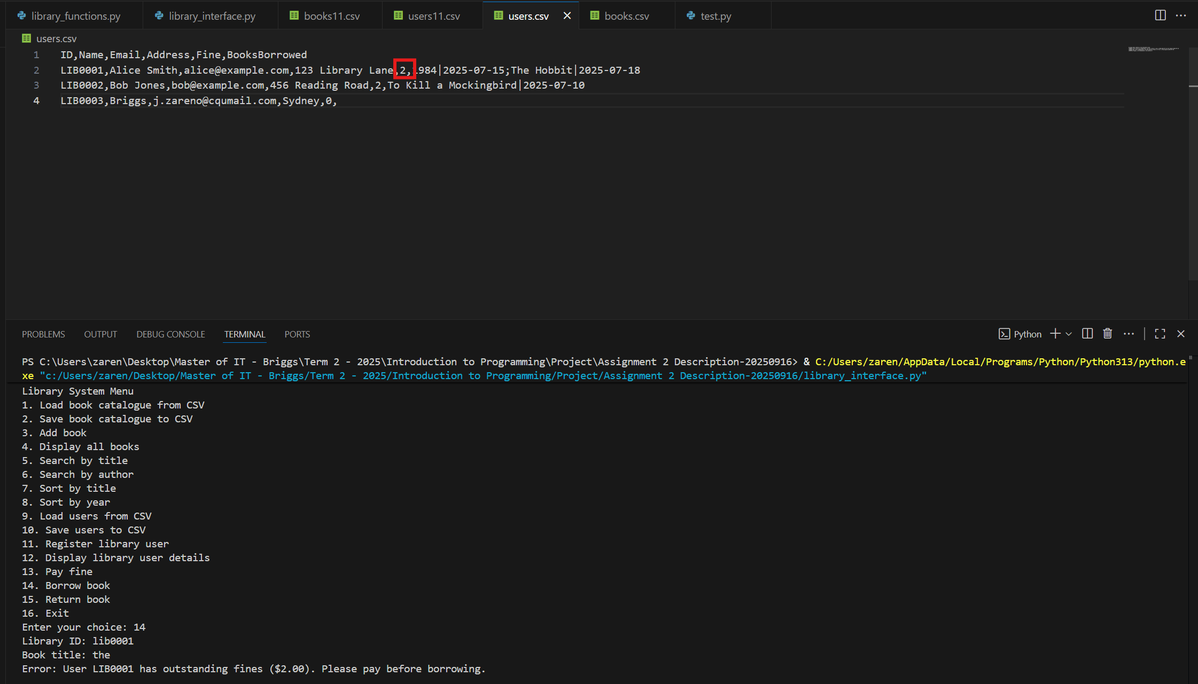
The screenshot above shows an instance where the Library ID LIB0001 has an outstanding fine of $2.00 based on the user catalogue, resulting the program printing an error message: “Error: User LIB0001 has outstanding fines ($2.00). Please pay before borrowing”.
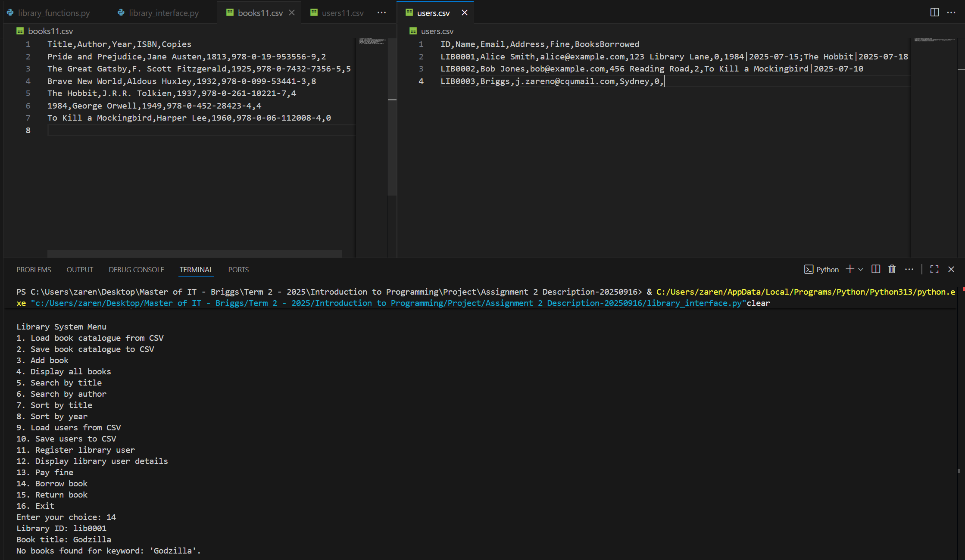
The screenshot above shows an instance where the user attempts to borrow a book that is not available in the catalogue (books11.csv). The system then prints an error message: ‘No books found for keyword: Godzilla’.
2. def return_book(users, catalogue, user_id, book_title, return_date)-> None
# Processes book return and updates inventory. Adds a fine if returned late.
Answer:
def return_book(users: List[dict], catalogue: List[dict], user_id: str, book_title: str, return_date: str) -> None:
"""
Return a borrowed book for a user, update fines and inventory, and confirm the outcome.

Args:
users (List[dict]): List of user dictionaries containing
(ID, Name, Email, Address, Fine, BooksBorrowed).
catalogue (List[dict]): List of book dictionaries containing
(Title, Author, Year, ISBN, Copies).
user_id (str): The ID of the user returning the book (case-insensitive).
book_title (str): Keyword to match the borrowed book title (case-insensitive).
return_date (str): The date the book is returned in YYYY-MM-DD format.

Returns:
None

Notes:
- Prints errors for: unknown user, no borrowed books, empty keyword,
no title match, or invalid date formats.
- If multiple matches are found, displays a table and prompts the user
to select which book to return.
- Computes a late fine at $2.00 per day past the due date and adds it to
the user's Fine.
- Removes the returned book from the user's BooksBorrowed and increments
the corresponding catalogue Copies.
"""
# 1. Find user
user = next((u for u in users if u.get("ID") == user_id.upper()), None)
if not user:
print(f"Error: No user found with ID {user_id}.")
return

# 2. Check the user's borrowed books
borrowed = user["BooksBorrowed"]
if not borrowed:
print(f"Error: User {user_id} has no borrowed books.")
return

# 3. Keyword match within user's borrowed list (case-insensitive)
search_term = book_title.strip().lower()

if not search_term:
print("Error: Search keyword cannot be empty.")
return

matches = [b for b in borrowed if search_term in str(b.get("Book Title", "")).lower()]

if not matches:
print(f"No borrowed books matched the keyword '{book_title}'.")
return

# 4. If multiple matches, show table and prompt which to return
if len(matches) > 1:
print(f"{len(matches)} borrowed books match '{book_title}':")
print(f"{'No.':^5} {'Title':^40} {'Due Date':^15}")
print("-" * 65)
for i, b in enumerate(matches, start=1):
print(f"{i:^5} {str(b.get('Book Title',''))[:40]:^40} {str(b.get('Due Date','')):^15}")

while True:
s = input("Enter the No. of the book to return (or 0 to cancel): ").strip()
if not s.isdigit():
print("Please enter a number.")
continue
n = int(s)
if n == 0:
print("Return cancelled.")
return
if 1 <= n <= len(matches):
chosen = matches[n - 1]
break
print(f"Please select a number between 1 and {len(matches)}, or 0 to cancel.")
else:
chosen = matches[0]
print("1 borrowed book matched:")
print(f"{'No.':^5} {'Title':^40} {'Due Date':^15}")
print("-" * 65)
print(f"{1:^5} {str(chosen.get('Book Title',''))[:40]:^40} {str(chosen.get('Due Date','')):^15}")

# 5. Parse dates
due_str = chosen.get("Due Date", "")
try:
due_dt = datetime.strptime(due_str, "%Y-%m-%d").date()
except ValueError:
print(f"Error: Stored due date '{due_str}' is invalid.")
return

try:
ret_dt = datetime.strptime(return_date.strip(), "%Y-%m-%d").date()
except ValueError:
print(f"Error: Return date '{return_date}' is invalid. Use YYYY-MM-DD.")
return

# 6. Compute late days and fine ($2/day)
late_days = (ret_dt - due_dt).days
added_fine = 0.0
if late_days > 0:
added_fine = 2.0 * late_days
try:
user["Fine"] = float(user.get("Fine", 0.0)) + added_fine
except (TypeError, ValueError):
user["Fine"] = added_fine

# 7. Remove from user's borrowed list
# Remove the exact dict object 'chosen'
try:
borrowed.remove(chosen)
except ValueError:
# Fallback: remove by matching title+due
borrowed[:] = [b for b in borrowed if not (
isinstance(b, dict)
and str(b.get("Book Title","")) == str(chosen.get("Book Title",""))
and str(b.get("Due Date","")) == str(chosen.get("Due Date",""))
)]

# 8. Increment catalogue copies for this title
title_exact = str(chosen.get("Book Title", ""))
cat_book = next((b for b in catalogue if str(b.get("Title","")) == title_exact), None)
if cat_book is not None:
try:
cat_book["Copies"] = int(cat_book.get("Copies", 0)) + 1
except (TypeError, ValueError):
cat_book["Copies"] = 1 # if it was invalid, reset to 1 on return

# 9. Confirmation
if added_fine > 0:
print(f"Returned '{title_exact}'. Late by {late_days} day(s): fine added ${added_fine:.2f}.")
print(f"New outstanding fine for {user['Name']} (ID: {user_id}): ${float(user['Fine']):.2f}")
else:
print(f"Returned '{title_exact}' on time. No fines added.")

Explanation:
The function return_book() is used to return a book for a user by searching titles with a keyword, return dates and updating the records. It accepts five arguments:
- users – a list of user dictionaries containing ID, Name, Email, Address, Fine, and BooksBorrowed.
- catalogue – a list of book dictionaries containing Title, Author, Year, ISBN, and Copies.
- user_id – the ID of the user borrowing the book, treated in a case-insensitive manner.
- book_title – a non-sensitive keyword to match against book titles, also case-insensitive.
- return_date – a return date (current date) where the user wants to return the book. It should follow the format YYYY-MM-DD.
The function begins by searching for the user using the inputted library ID. This is done with the next() function and an iterator to find the matching ID. If the Library ID is not found, the program prints the error message: “Error: No user found with ID {user_id}”
If the user exists, the function retrieves their BooksBorrowed list and stores it in the variable borrowed. This list contains all the books currently borrowed by the user.
- If the list is empty, it means the user has no books checked out. In that case, the program prints: “Error: User {user_id} has no borrowed books.” and exits the function.
Next, the input book_title is cleaned using strip() to remove leading and trailing spaces and converted to lowercase using lower() for case-insensitive matching. If the keyword is empty after stripping, the program prints: “Error: Search keyword cannot be empty.” and exits the function.
The program then searches through the user’s BooksBorrowed list to find entries where the book title contains the keyword. These matches are stored in the matches list.
- If no matches are found, the program prints: “No borrowed books matched the keyword '{book_title}'.” and stops the process.
If multiple matches are found, the program prints the total number of matches and displays them in a table format with columns for No., Title, and Due Date. The user is then prompted to select the book to return by entering its corresponding number. Input validation ensures the following:
- If the input is not numeric, the program prints: “Please enter a number.”
- If the input is 0, the process is cancelled and the function returns.
- If the number is within range, the corresponding book is stored in the variable chosen.
- If the number is outside the valid range, the program prompts again with:
“Please select a number between 1 and {len(matches)}, or 0 to cancel.”
If only one match is found that book is automatically selected and stored in chosen. The program also displays a table with the details of the single matching book (No., Title, and Due Date) for confirmation.
After that, the program retrieves the book’s due date from the selected entry (chosen) and stores it in due_str. It then attempts to convert this string into a datetime.date object using the format YYYY-MM-DD.
- If the stored due date cannot be parsed correctly (for example, if the string is corrupted or in the wrong format), a ValueError is raised. In that case, the program prints: “Error: Stored due date '{due_str}' is invalid.” and exits the return process.
The function then takes the return_date entered by the user, removes any extra spaces with strip(), and attempts to convert it into a datetime.date object using the same YYYY-MM-DD format.
- If the input return date is invalid (e.g., typed incorrectly as 2025/09/30 or with invalid values like 2025-13-40), the program raises a ValueError. It then prints: “Error: Return date '{return_date}' is invalid. Use YYYY-MM-DD.” and exits the function.
The function then calculates the difference between the return date (ret_dt) and the due date (due_dt) in days. The result is stored in the variable late_days.
- If late_days is greater than 0, it means the book was returned late.
- The fine is calculated at $2.00 per day overdue, and the result is stored in the variable added_fine.
The program then updates the user’s outstanding fine.
- It first tries to retrieve the current value of the user’s Fine, convert it to a float, and add the new fine amount.
- If the stored fine value is invalid (e.g., not numeric), a TypeError or ValueError may occur. In that case, the program replaces the Fine field with just the new fine amount (added_fine).
The program first attempts to remove the exact dictionary object chosen from the user’s BooksBorrowed list using borrowed.remove(chosen).
- If this fails with a ValueError (for example, if the stored object is not identical but has the same values), the function falls back to removing by matching both the Book Title and the Due Date.
- This ensures that the correct book entry is removed, even if the object reference is slightly different.
After the book is removed from the user’s list, the program updates the catalogue to reflect that one copy has been returned. It searches the catalogue for a book with the exact same title (title_exact).
- If found, it increases the Copies count by 1.
- If the Copies value was invalid (not an integer), the program resets it to 1, since the book has just been returned.
Finally, the program prints a confirmation message.
- If the book was returned late, the message includes how many days overdue it was and the fine that was added, followed by the user’s updated outstanding fine.
- If the book was returned on time, the program confirms the return and specifies that no fines were added.
Testing:
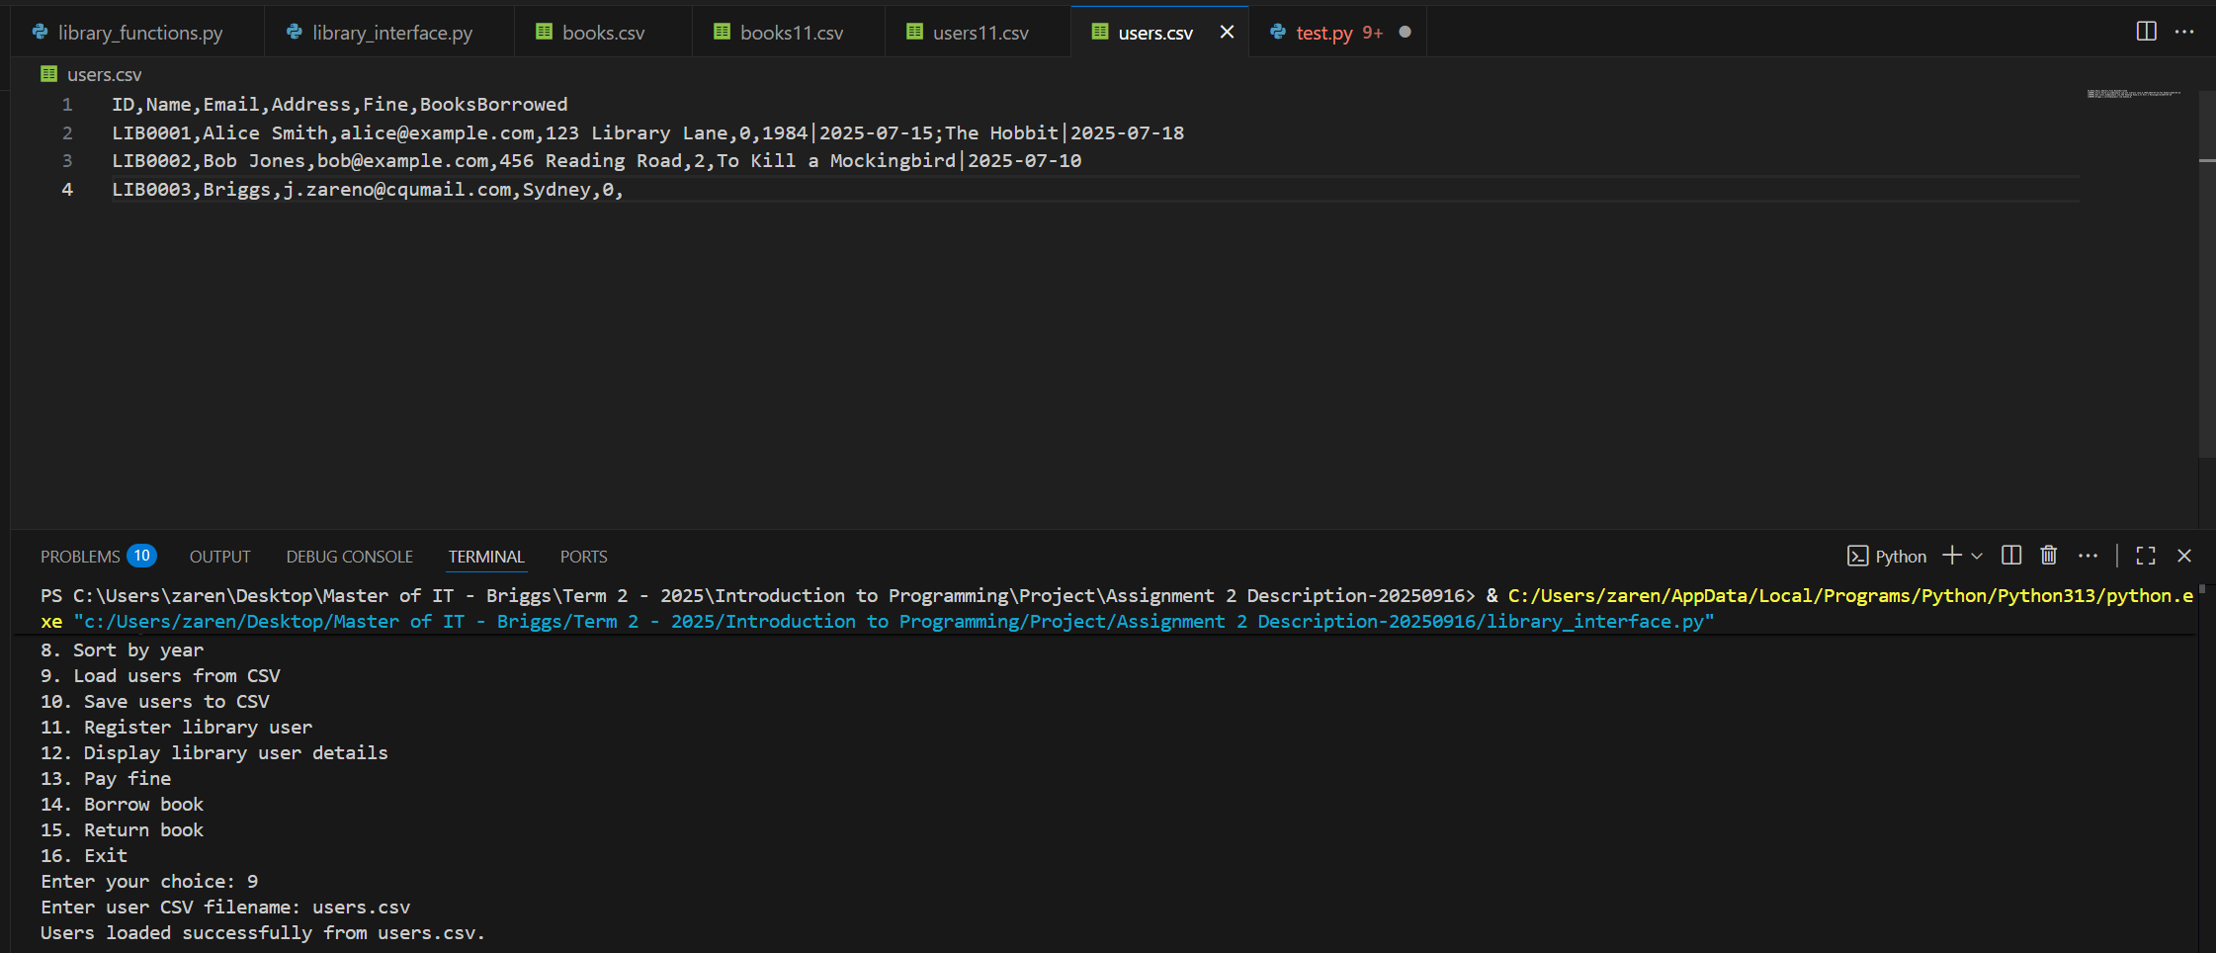
The screenshot above shows how users.csv was loaded into the users catalogue and its content (displayed above).
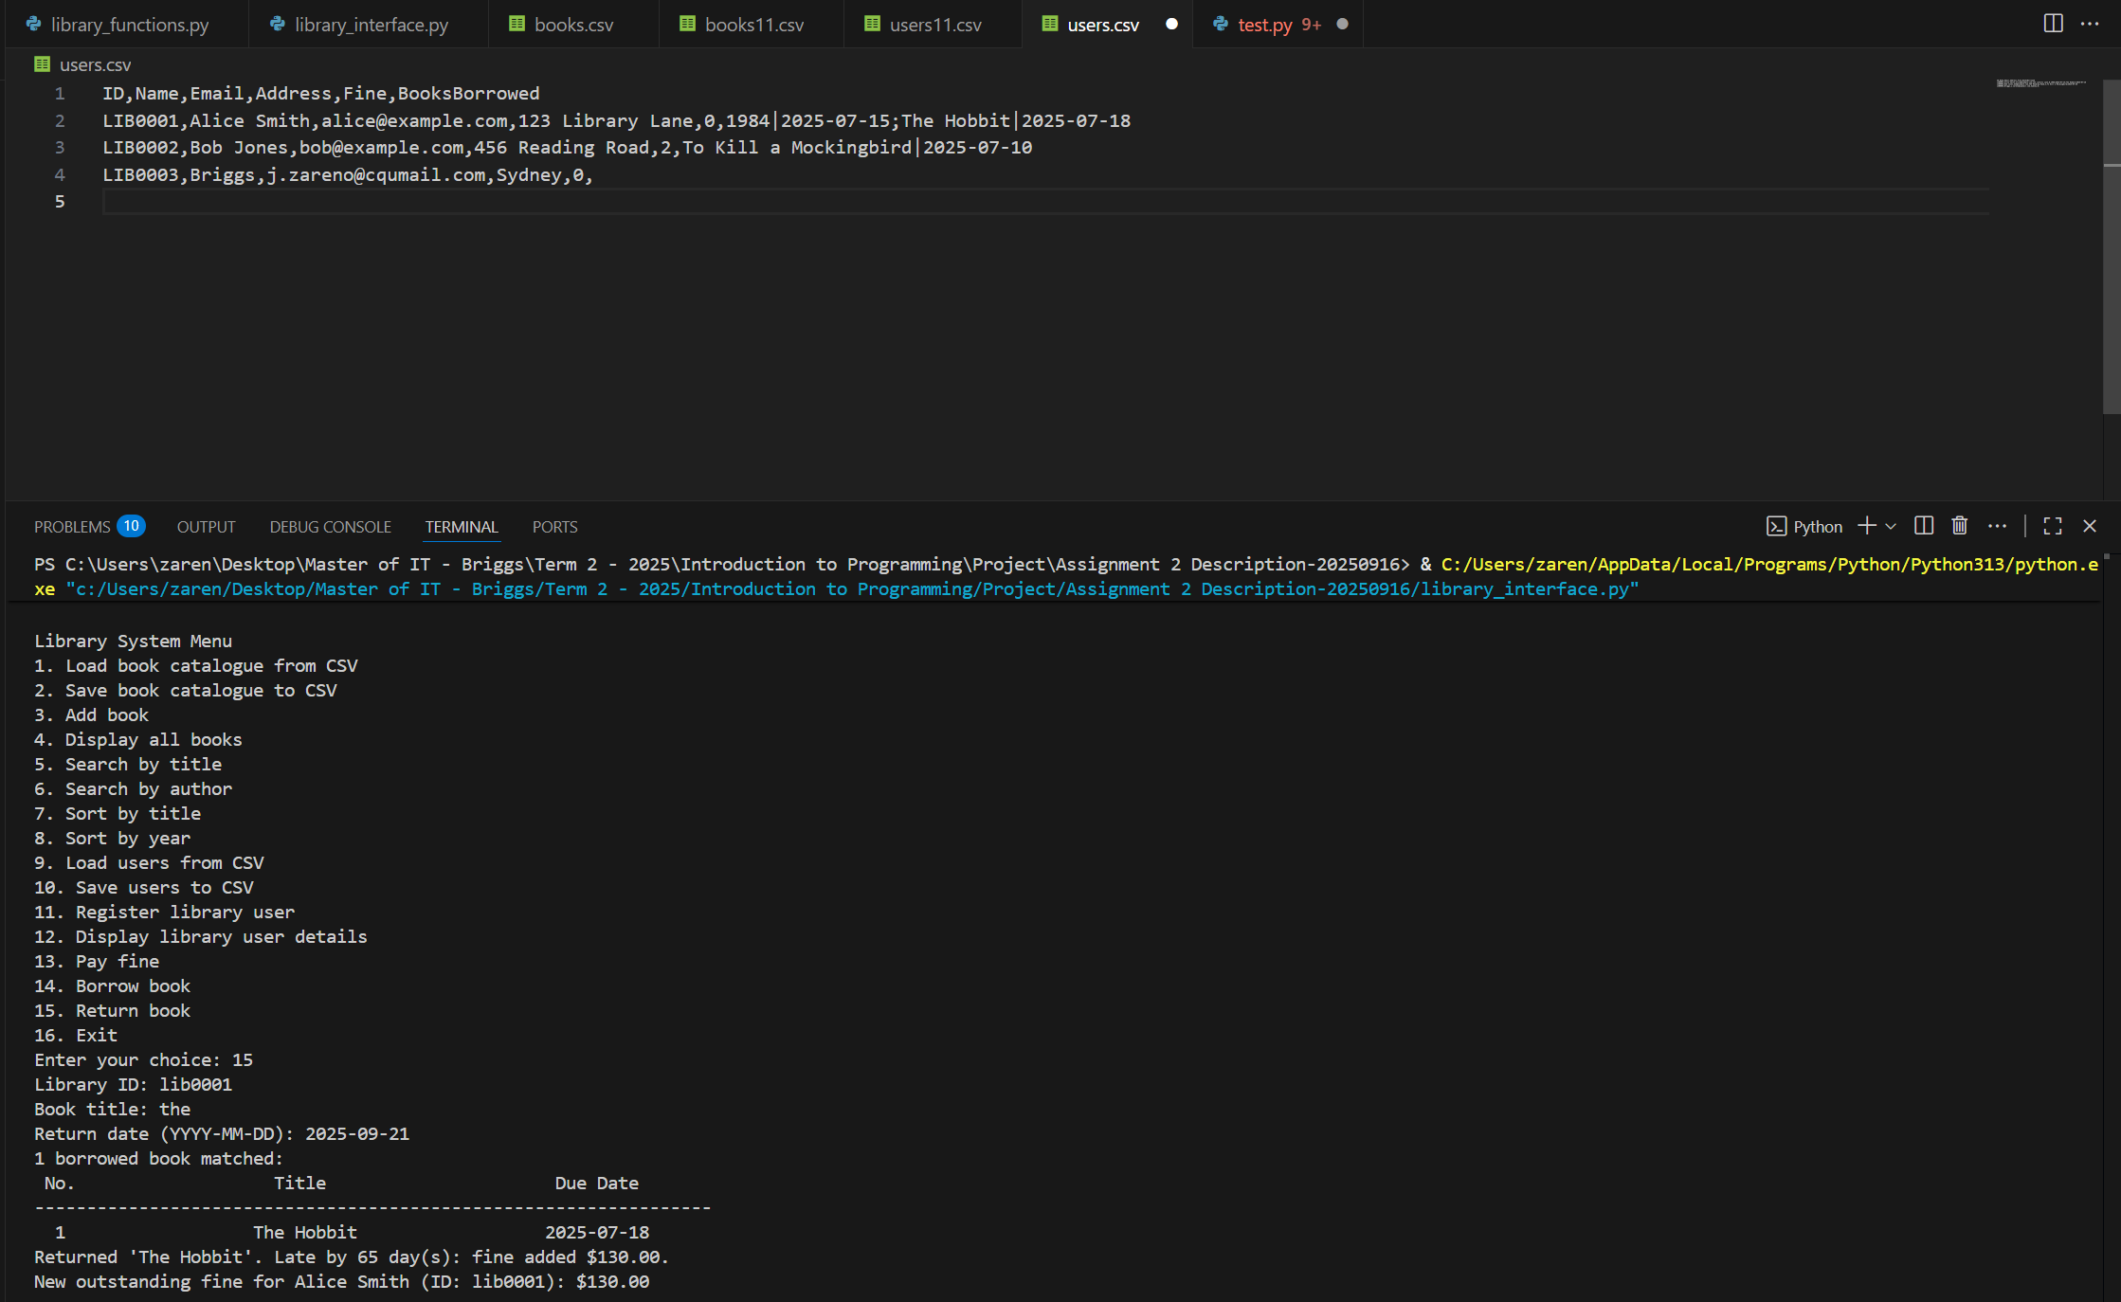
The screenshot above shows how the user selected option 15 and attempted to borrow/return a book. The user provided the necessary details: Library ID = lib0001 (case-insensitive), Book Title = ‘the’ (entered as a keyword), and Return Date = 2025-09-21 (in YYYY-MM-DD format, representing the date the user planned to return the book, which in this case is today).
Once the information was submitted, the program displayed the borrowed books associated with the given Library ID, showing the No., Title, and Due Date (the expected return date). In this example, the program displayed the message:
“Returned ‘The Hobbit’. Late by 65 day(s): fine added $130.00”
followed by another line confirming the updated fine:
“New outstanding fine for Alice Smith (ID: lib0001) is $130.00.”
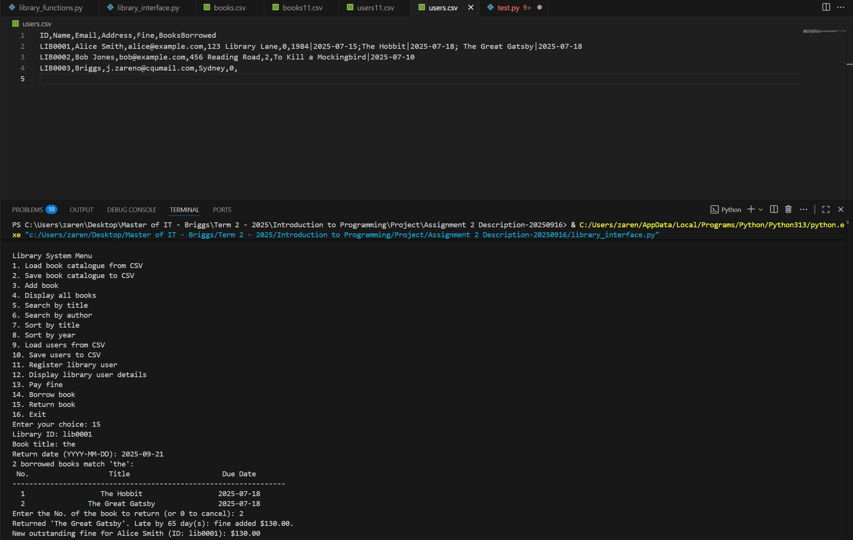
The screenshot above shows how the user attempted to return books using the keyword ‘the’, which displayed all the books the user had borrowed. In this case, the results included “The Hobbit” and “The Great Gatsby.”
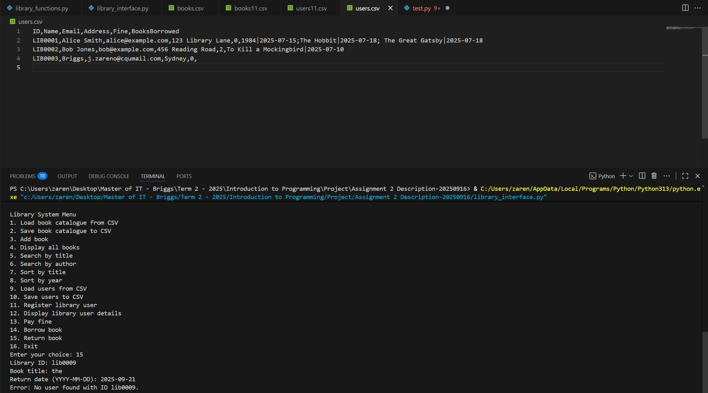
The screenshot above shows how the user attempted to search for a non-existent Library ID, in this case ‘lib0009’. Since no record matched the input, the program displayed the error message: “Error: No user found with ID lib0009.”
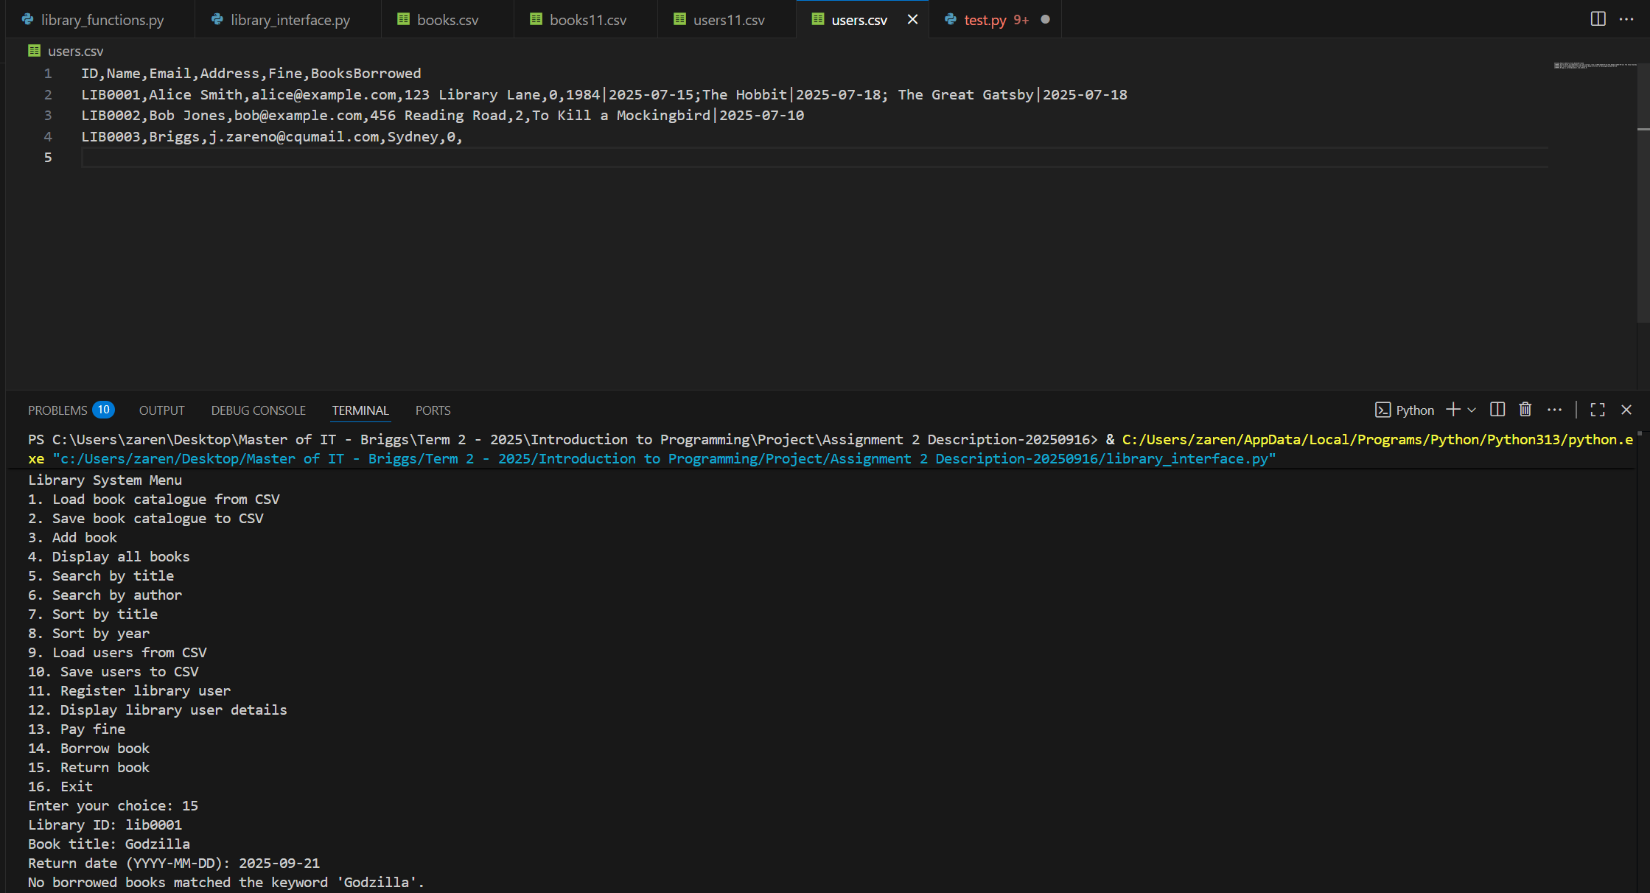
The screenshot above shows a user attempting to search for a borrowed book with the title “Godzilla” using the Library ID lib0001. Since no borrowed books matched the keyword, the program displayed the error message:
“No borrowed books matched the keyword ‘Godzilla’.”
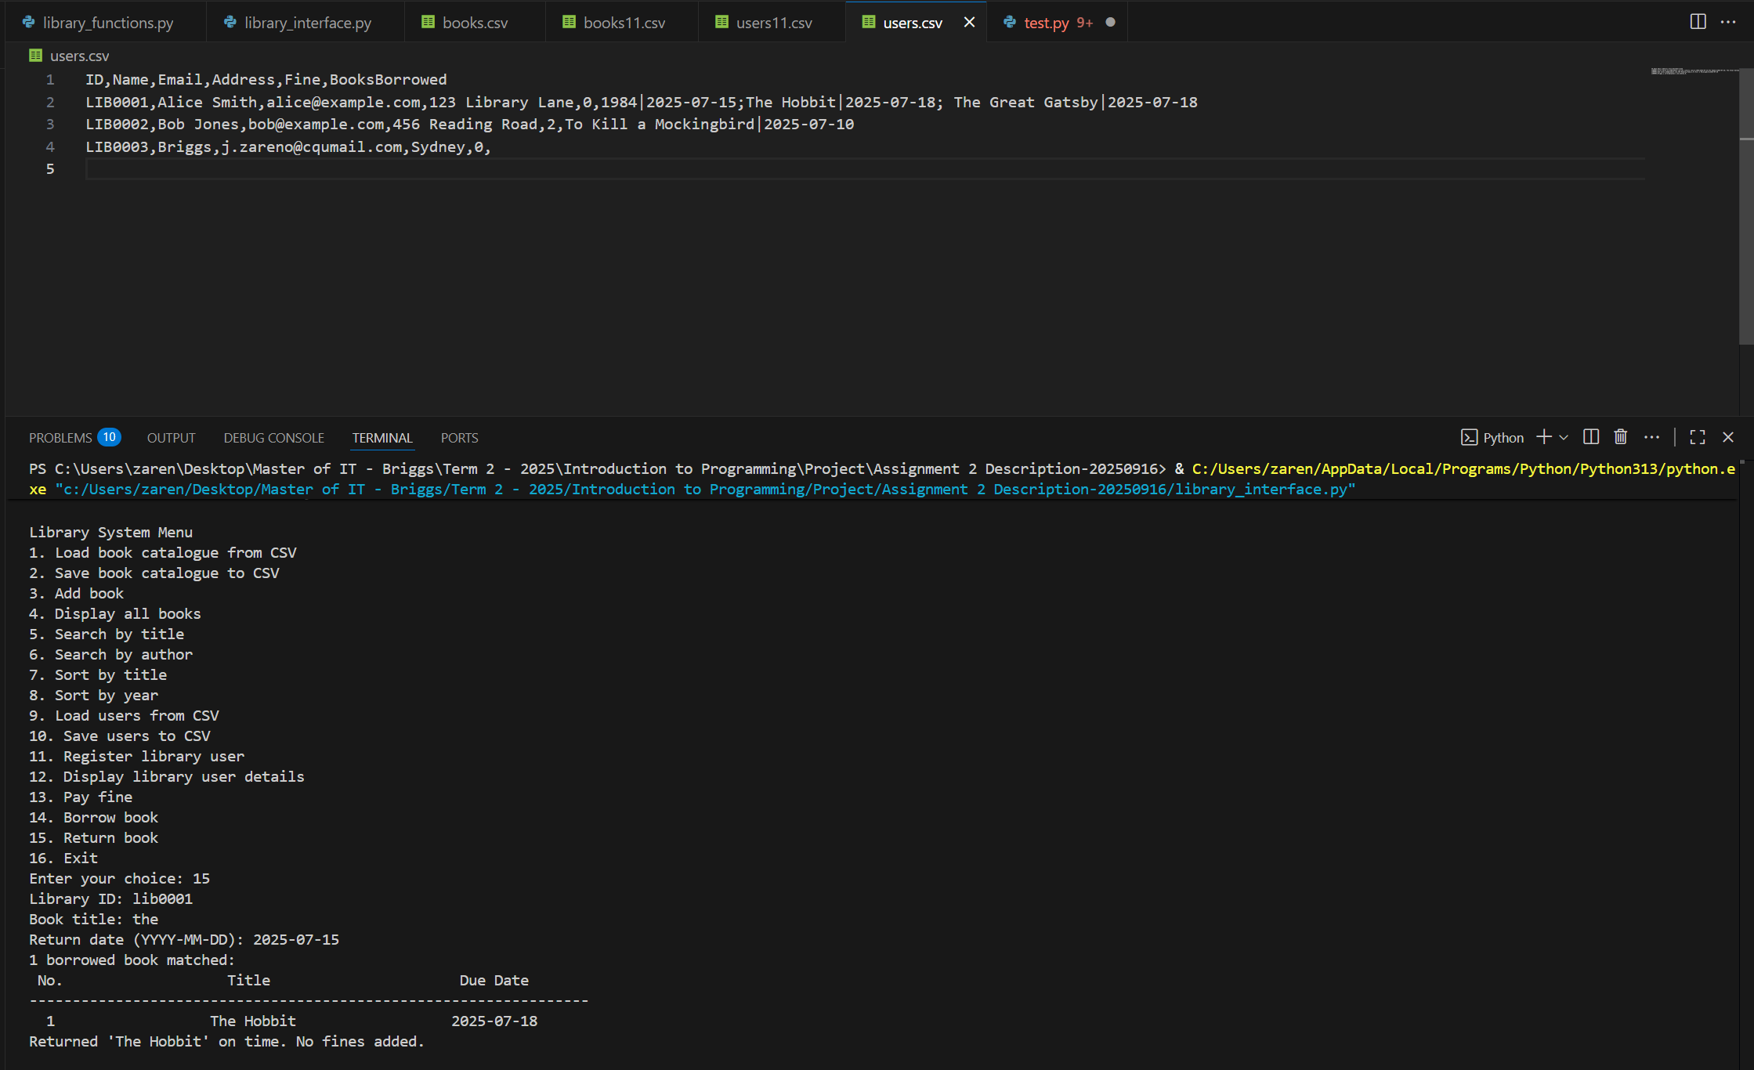
The screenshot above shows how the user successfully returned a borrowed book without any fines. After the return process was completed, the program displayed the updated user details and confirmed the action indicating that no outstanding fines were applied.
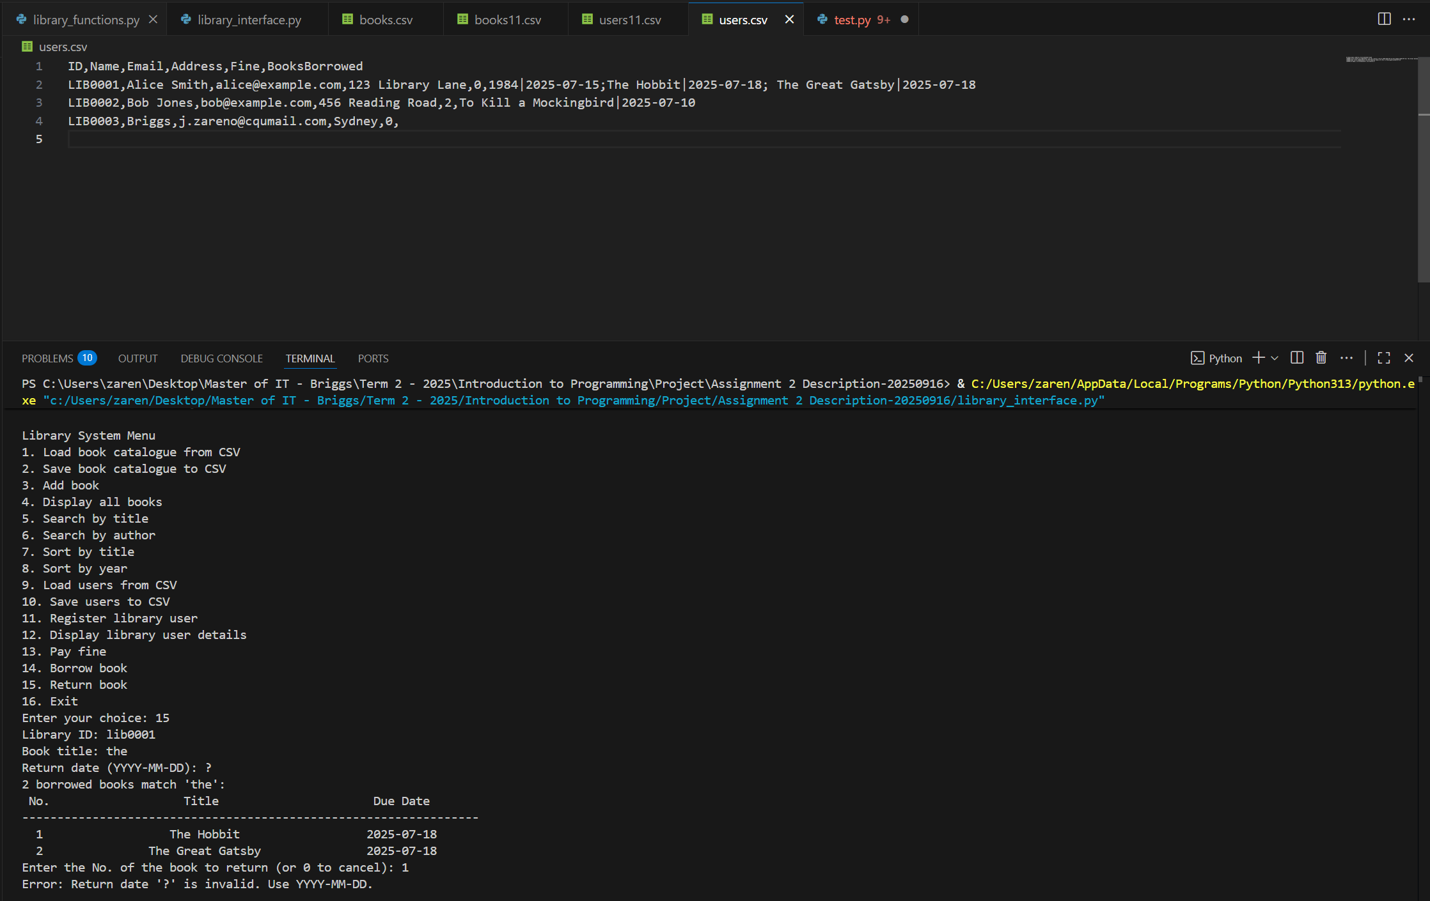
The screenshot above shows how the user entered an incorrect format in the Return Date field, which requires the format YYYY-MM-DD. Since the Library ID provided was valid, the program first displayed the details of the user’s borrowed books. However, because the return date input was invalid, the program then displayed the error message:
“Error: return date ‘?’ is invalid. Use YYYY-MM-DD.”
After showing this message, the program returned to the main() function, which is the option selection prompt.

